**2023S – Database Design & SQL   
SQL Project – 8%   
---------------------------------------------------------------------------------------------------------------------**For the individual assignment I have decided to use the database tables which are from our group project on **Design of Car Rental System**. There are all together eight tables with their respective attributes. Now, first I will write down the queries to create and insert data into the individual table so that we can write other queries later.

**Create table Customer_142:**

CREATE TABLE Customer_142 (

Driver_License_Number VARCHAR2(20) PRIMARY KEY,

First_Name VARCHAR2(100) NOT NULL,

Last_Name VARCHAR2(100) NOT NULL,

Street VARCHAR2(255) NOT NULL,

City VARCHAR2(50) NOT NULL,

Postal_Code VARCHAR2(10) NOT NULL,

Province VARCHAR2(50) NOT NULL,

Phone VARCHAR2(15) NOT NULL,

Email VARCHAR2(150) NOT NULL,

Member_ID VARCHAR2(20),

Gender CHAR(1)

);

**Create table Car_142:**

CREATE TABLE Car_142 (

Chassis_Number VARCHAR2(25) PRIMARY KEY,

Model VARCHAR2(100) NOT NULL,

Model_Number VARCHAR2(50) NOT NULL,

Is_Available CHAR(1) NOT NULL,

Mileage NUMBER(10,2) NOT NULL,

No_Of_Person INT NOT NULL,

Price_Per_Day NUMBER(10,2) NOT NULL,

Late_Fee_Per_Hour NUMBER(10,2) NOT NULL,

No_Of_Luggage INT NOT NULL,

Insurance_Code VARCHAR2(20) NOT NULL,

Make VARCHAR2(100),

Condition VARCHAR2(50)

);

**Create table Insurance _142:**

CREATE TABLE Insurance_142 (

Insurance_Code VARCHAR2(20) PRIMARY KEY,

Coverage_Type VARCHAR2(100) NOT NULL,

Cost_Per_Day NUMBER(10,2) NOT NULL,

Name VARCHAR2(150)

);

**Create table Location _142:**

CREATE TABLE Location_142 (

Location_ID INT PRIMARY KEY,

Street VARCHAR2(255) NOT NULL,

City VARCHAR2(50) NOT NULL,

Postal_Code VARCHAR2(10) NOT NULL,

Province VARCHAR2(50) NOT NULL

);

**Create table Office _142:**

CREATE TABLE Office_142 (

Office_ID INT PRIMARY KEY,

Name VARCHAR2(100) NOT NULL,

Address VARCHAR2(255) NOT NULL,

Postal_Code VARCHAR2(10) NOT NULL,

Province VARCHAR2(50)

);

**Create table Employee _142:**

CREATE TABLE Employee_142 (

Employee_ID INT PRIMARY KEY,

First_Name VARCHAR2(100) NOT NULL,

Last_Name VARCHAR2(100) NOT NULL,

Address VARCHAR2(255) NOT NULL,

Office_ID INT NOT NULL,

Gender CHAR(1),

Age INT

);

**Create table Payment _142:**

CREATE TABLE Payment_142 (

Payment_ID INT PRIMARY KEY,

Payment_Type VARCHAR2(50) NOT NULL,

Payment_Due_Date DATE NOT NULL,

Total_Amount NUMBER(10,2) NOT NULL,

Tax_Amount NUMBER(10,2) NOT NULL,

Payment_Status VARCHAR2(50) NOT NULL,

Driver_License_Number VARCHAR2(20) NOT NULL,

Contract_ID INT NOT NULL,

Advance_Amount NUMBER(10,2),

Cancelation_Charge NUMBER(10,2),

Late_Fee NUMBER(10,2)

);

**Create table Contract _142:**

CREATE TABLE Contract_142 (

Contract_ID INT PRIMARY KEY,

Start_Date DATE NOT NULL,

End_Date DATE NOT NULL,

Contract_Status VARCHAR2(50) NOT NULL,

Return_Date DATE NOT NULL,

Amount NUMBER(10,2) NOT NULL,

Chassis_Number VARCHAR2(25) NOT NULL,

Driver_License_Number VARCHAR2(20) NOT NULL,

Office_ID INT NOT NULL,

Location_ID INT NOT NULL

);

**Insert data into Customer_142 table:**

INSERT INTO Customer_142 (Driver_License_Number, First_Name, Last_Name, Street, City, Postal_Code, Province, Phone, Email, Member_ID, Gender)

VALUES ('DL12345', 'John', 'Doe', '123 Main St', 'New York', '10001', 'NY', '1234567890', 'john.doe@email.com', 'M123', 'M');

**Insert data into Car _142 table:**

INSERT INTO Car_142 (Chassis_Number, Model, Model_Number, Is_Available, Mileage, No_Of_Person, Price_Per_Day, Late_Fee_Per_Hour, No_Of_Luggage, Insurance_Code, Make, Condition)

VALUES ('CH12345', 'Sedan', 'S123', 'Y', 50000, 5, 100, 10, 4, 'IC123', 'Toyota', 'New');

**Insert data into Insurance _142 table:**

INSERT INTO Insurance_142 (Insurance_Code, Coverage_Type, Cost_Per_Day, Name)

VALUES ('IC123', 'Full', 15, 'Best Insurance');

**Insert data into Location _142 table:**

INSERT INTO Location_142 (Location_ID, Street, City, Postal_Code, Province)

VALUES (1, '456 Market St', 'Los Angeles', '90001', 'CA');

**Insert data into Office _142 table:**

INSERT INTO Office_142 (Office_ID, Name, Address, Postal_Code, Province)

VALUES (1, 'Main Office', '789 Central St', '20001', 'DC');

**Insert data into Employee _142 table:**

INSERT INTO Employee_142 (Employee_ID, First_Name, Last_Name, Address, Office_ID, Gender, Age)

VALUES (1, 'Jane', 'Smith', '101 Central St', 1, 'F', 30);

**Insert data into Payment _142 table:**

INSERT INTO Payment_142 (Payment_ID, Payment_Type, Payment_Due_Date, Total_Amount, Tax_Amount, Payment_Status, Driver_License_Number, Contract_ID, Advance_Amount, Cancelation_Charge, Late_Fee)

VALUES (1, 'Credit Card', TO_DATE('2023-08-10', 'YYYY-MM-DD'), 500, 50, 'Pending', 'DL12345', 1, 100, 20, 10);

**Insert data into Contract _142 table:**

INSERT INTO Contract_142 (Contract_ID, Start_Date, End_Date, Contract_Status, Return_Date, Amount, Chassis_Number, Driver_License_Number, Office_ID, Location_ID)

VALUES (1, TO_DATE('2023-08-01', 'YYYY-MM-DD'), TO_DATE('2023-08-10', 'YYYY-MM-DD'), 'Active', TO_DATE('2023-08-10', 'YYYY-MM-DD'), 450, 'CH12345', 'DL12345', 1, 1);

Now, let’s begin with writing the 50 SQL queries based on the categories provided on assignment:

1. **Select columns from a table:**

SELECT First_Name, Last_Name, Email FROM Customer_142;

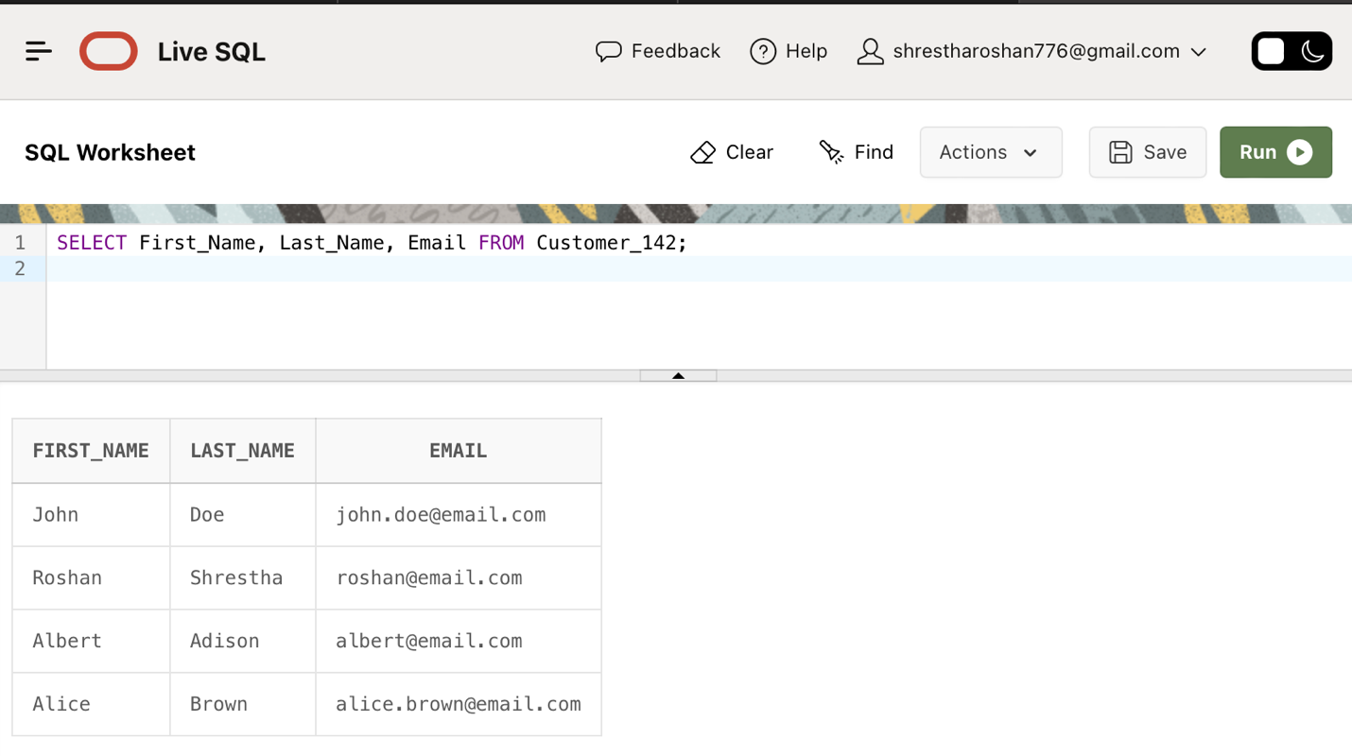

1. **Computed Columns:**

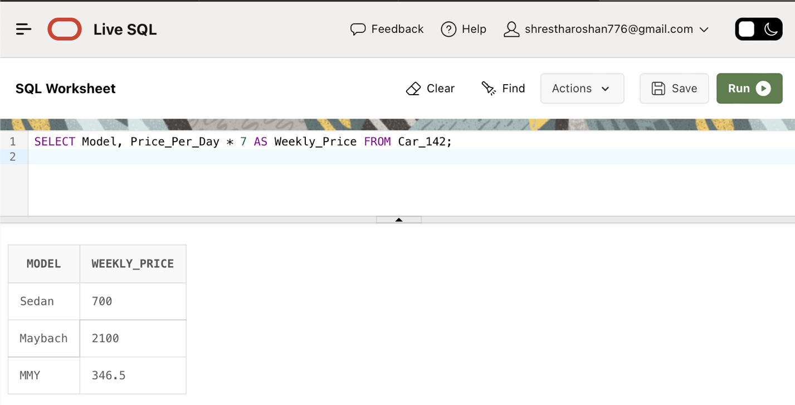SELECT Model, Price_Per_Day * 7 AS Weekly_Price FROM Car_142;

1. **IS NULL:**

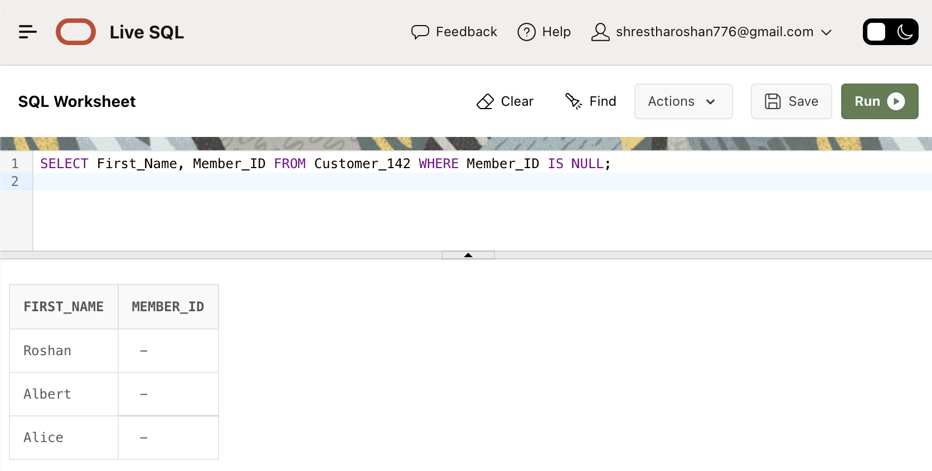SELECT First_Name, Member_ID FROM Customer_142 WHERE Member_ID IS NULL;

1. **IS NOT NULL:**

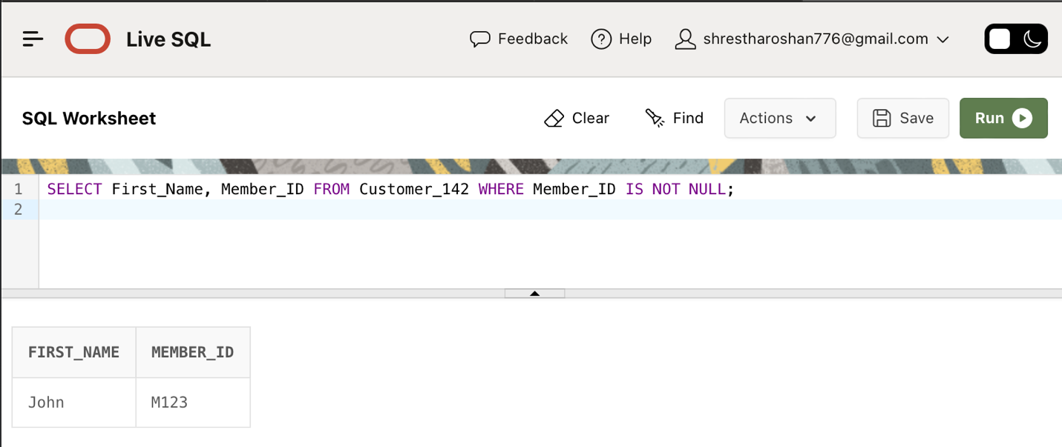SELECT First_Name, Member_ID FROM Customer_142 WHERE Member_ID IS NOT NULL;

1. **String concatenation:**

SELECT First_Name || ' ' || Last_Name AS Full_Name FROM Customer_142;

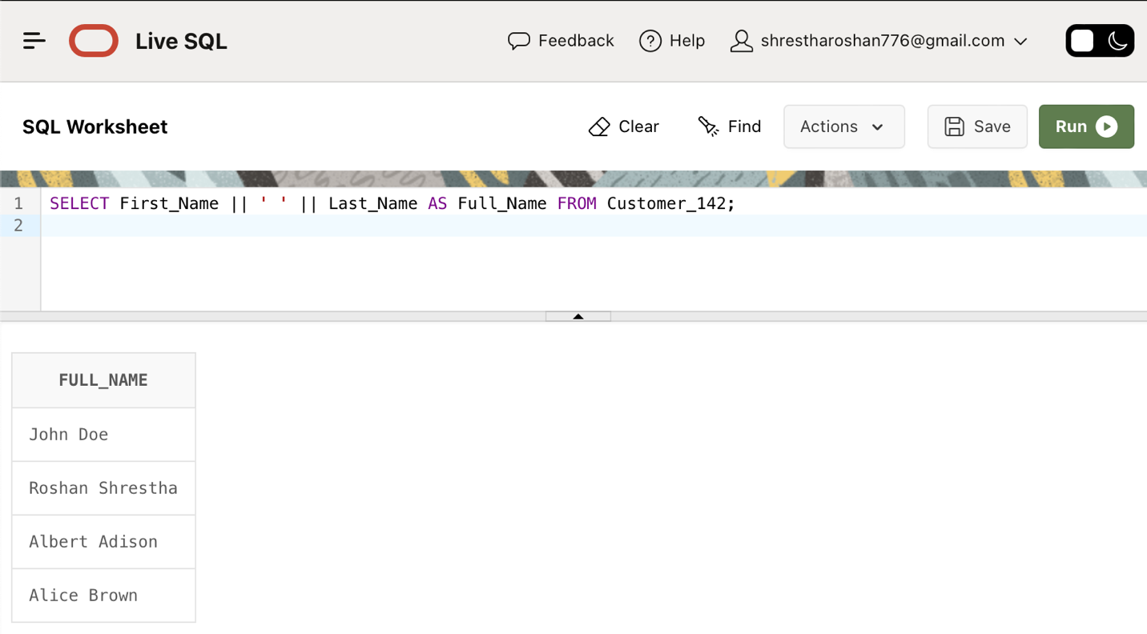

1. **Distinct Keyword:**

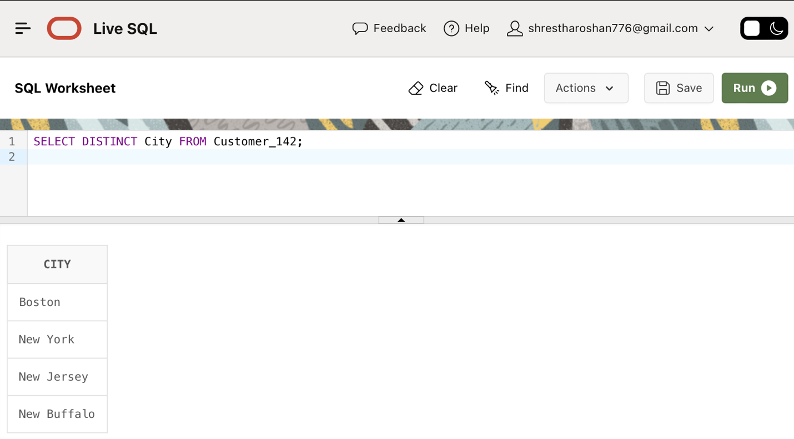SELECT DISTINCT City FROM Customer_142;

1. **NOT operator:**

SELECT Model FROM Car_142 WHERE NOT Model = 'Sedan';

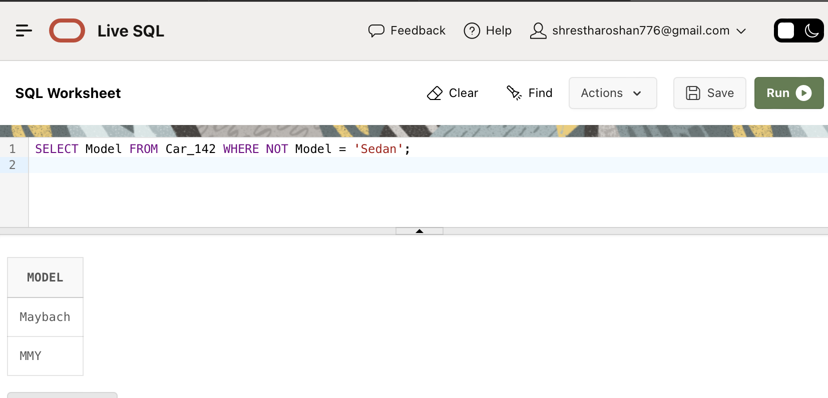

1. **BETWEEN Operator:**

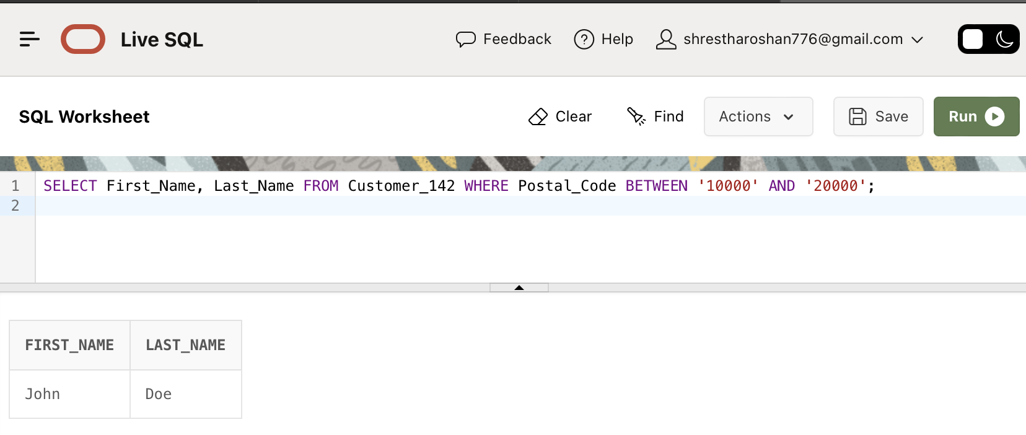SELECT First_Name, Last_Name FROM Customer_142 WHERE Postal_Code BETWEEN '10000' AND '20000';

1. **IN Operator:**

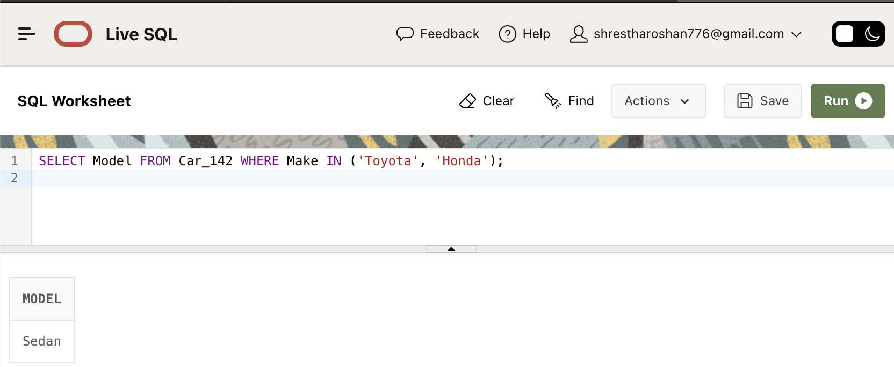SELECT Model FROM Car_142 WHERE Make IN ('Toyota', 'Honda');

1. **NOT IN:**

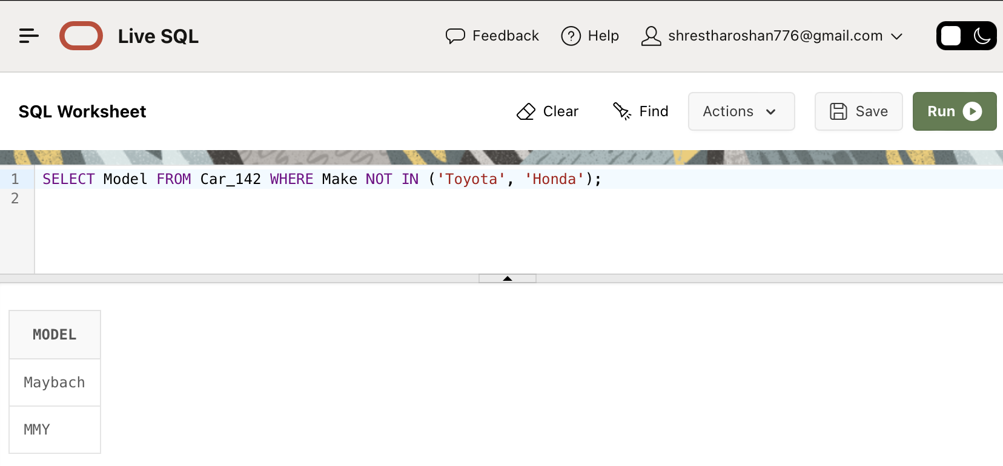SELECT Model FROM Car_142 WHERE Make NOT IN ('Toyota', 'Honda');

1. **LIKE Operator:**

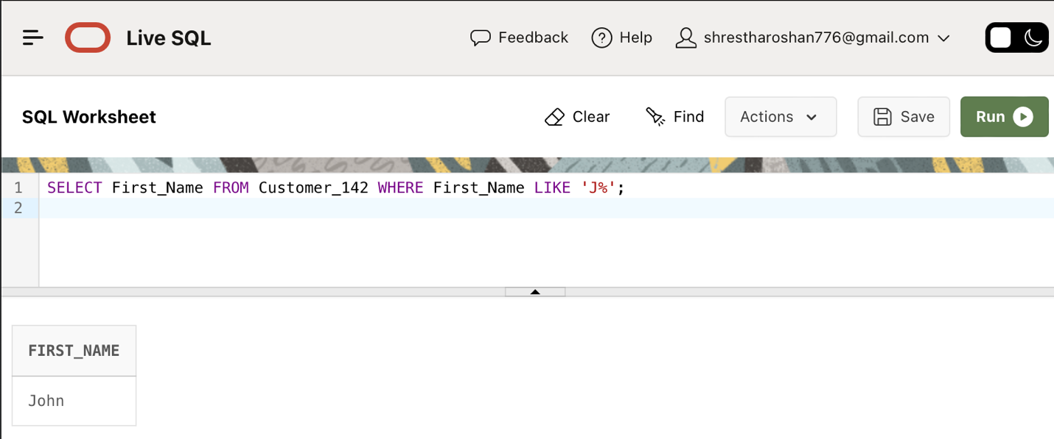SELECT First_Name FROM Customer_142 WHERE First_Name LIKE 'J%';

1. **Comparison Operator (<,<,=):**

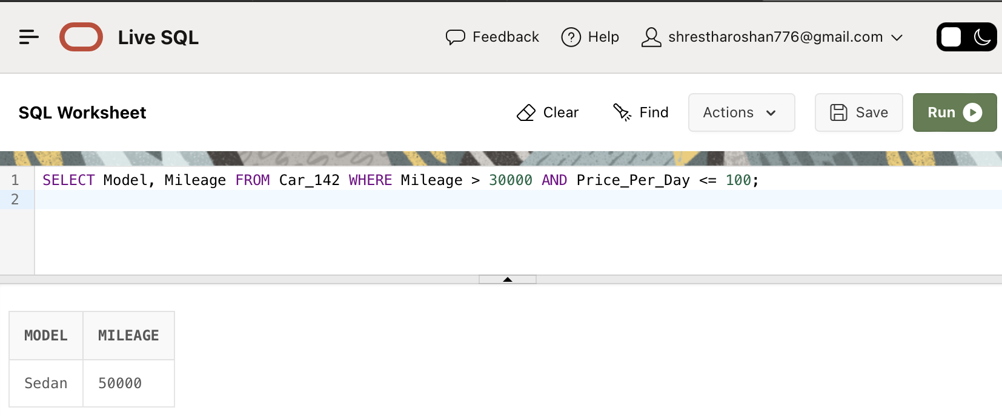SELECT Model, Mileage FROM Car_142 WHERE Mileage > 30000 AND Price_Per_Day <= 100;

1. **Comparision Operator (=):**

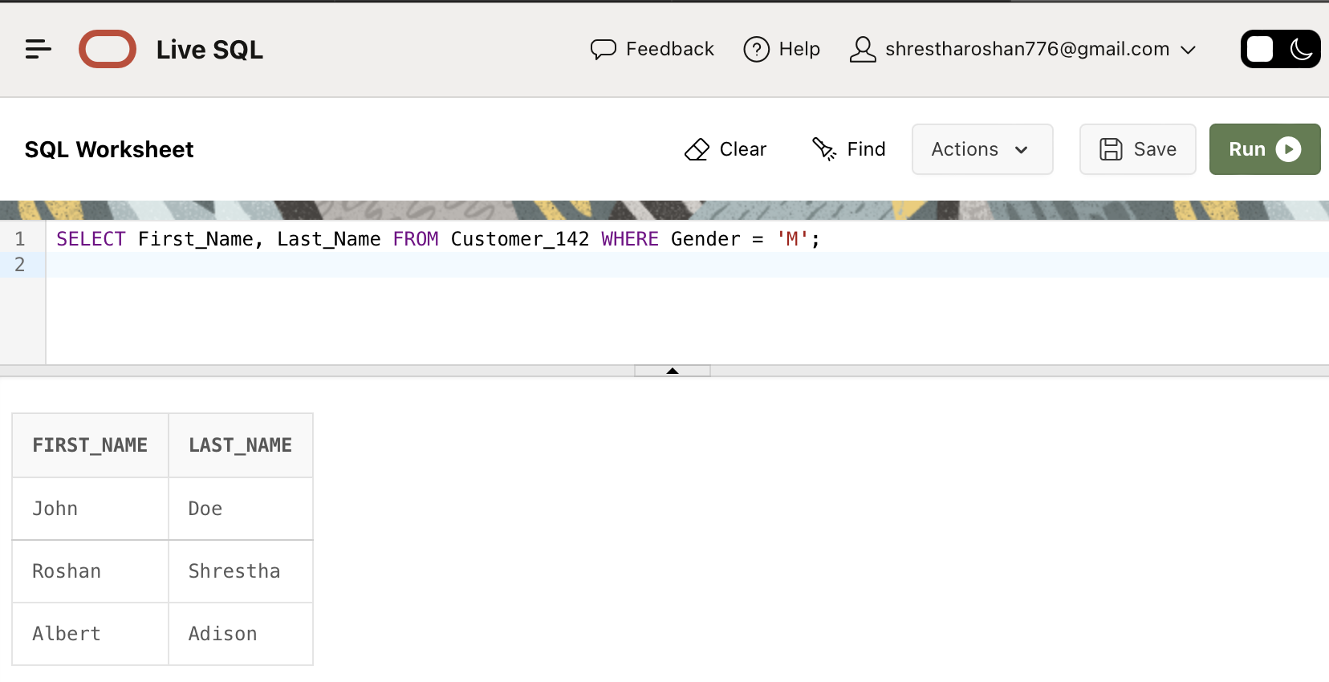SELECT First_Name, Last_Name FROM Customer_142 WHERE Gender = 'M';

1. **LIKE and IN operator:**

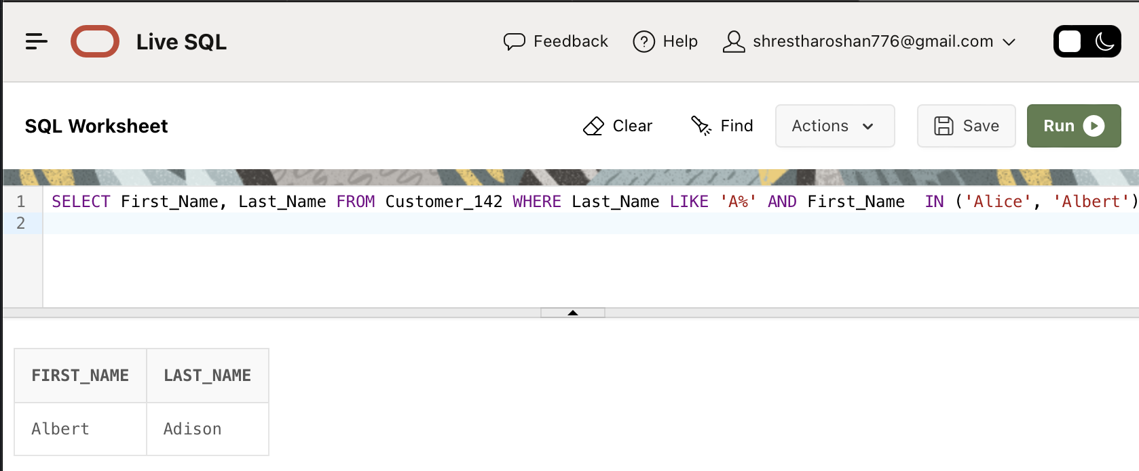SELECT First_Name, Last_Name FROM Customer_142 WHERE Last_Name LIKE 'A%' AND First_Name IN ('Alice', 'Albert');

1. **AND NOT Operator:**

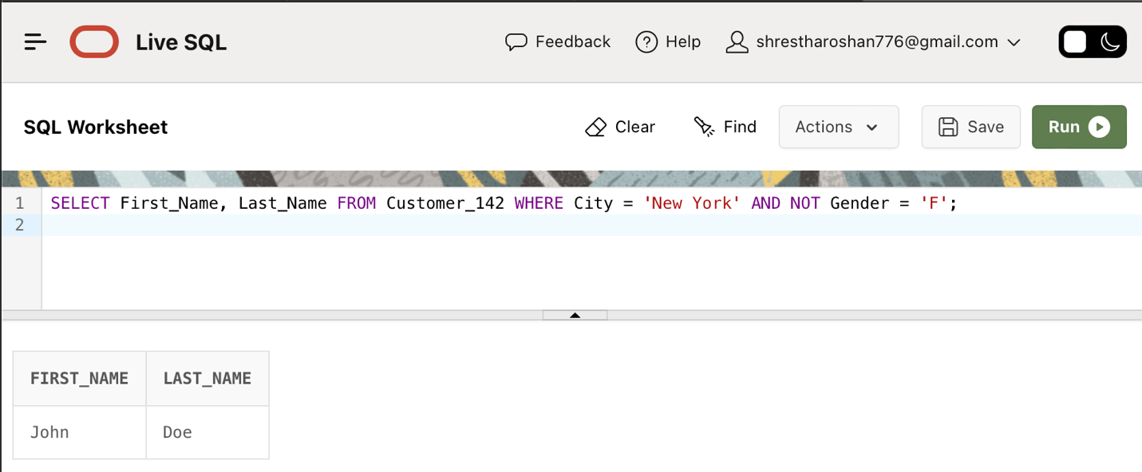SELECT First_Name, Last_Name FROM Customer_142 WHERE City = 'New York' AND NOT Gender = 'F';

1. **AND Operator:**

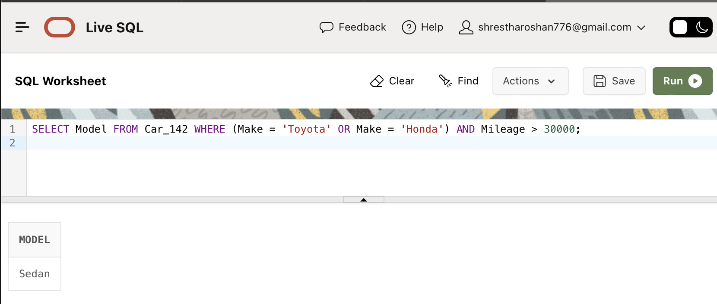SELECT Model FROM Car_142 WHERE (Make = 'Toyota' OR Make = 'Honda') AND Mileage > 30000;

1. **ORDER BY operator:**

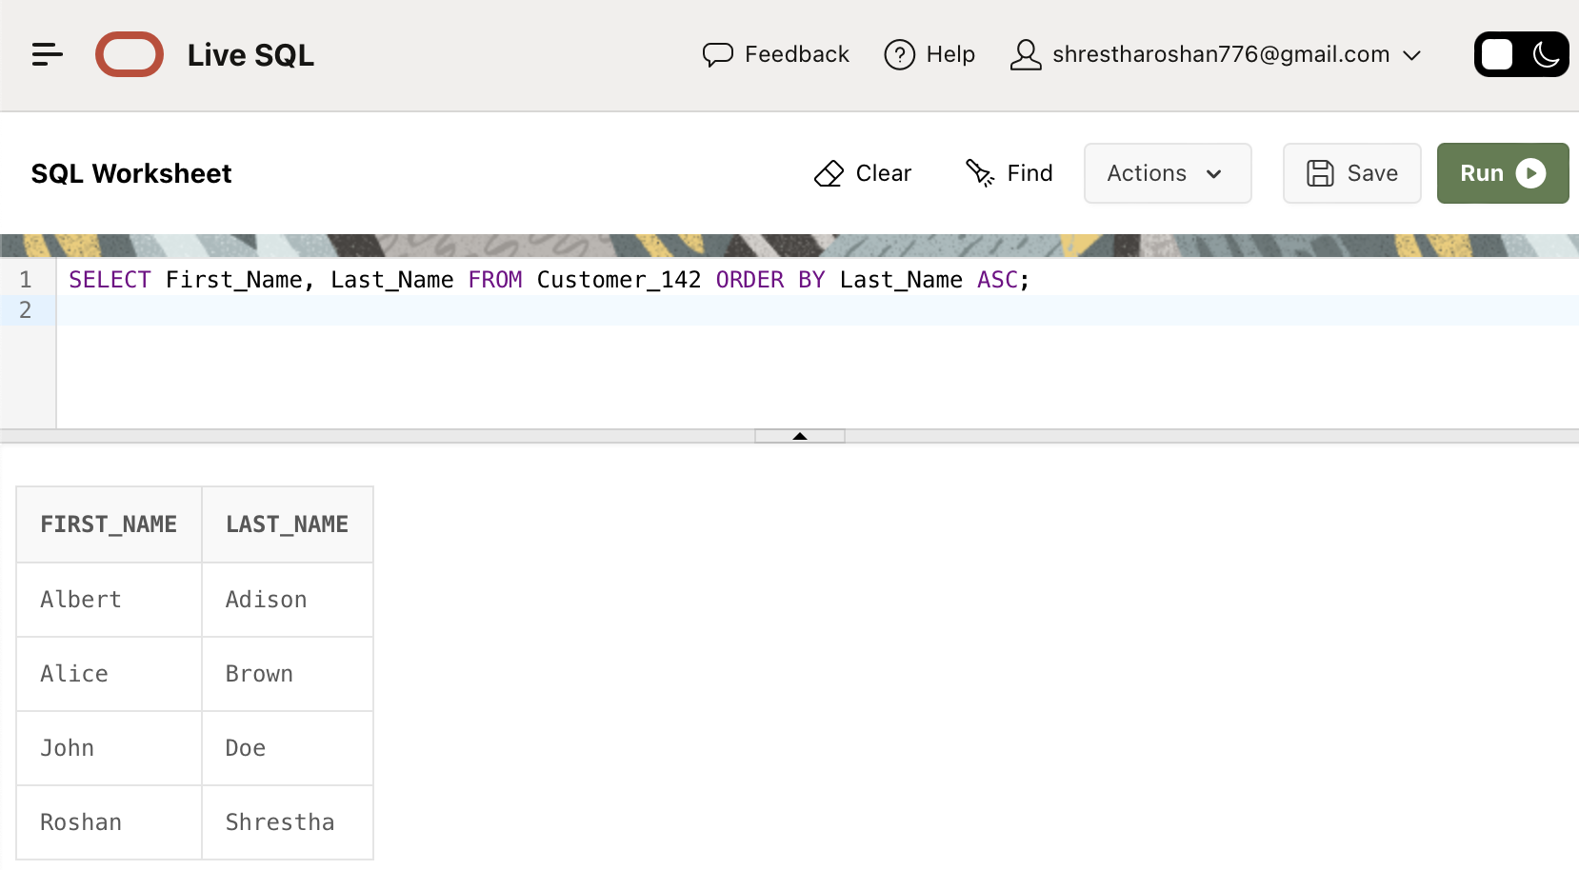SELECT First_Name, Last_Name FROM Customer_142 ORDER BY Last_Name ASC;

1. **AVG function:**

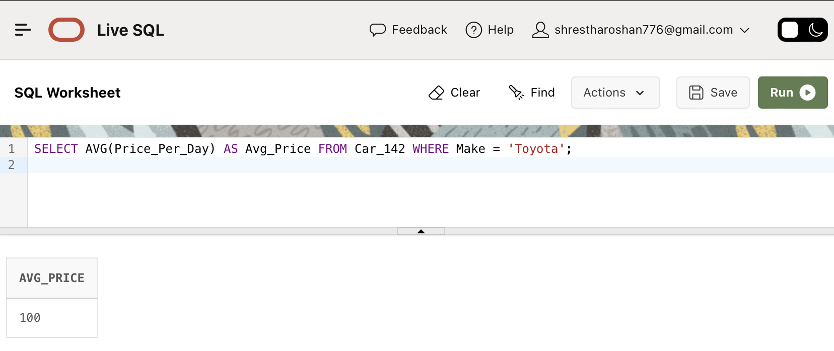SELECT AVG(Price_Per_Day) AS Avg_Price FROM Car_142 WHERE Make = 'Toyota';

1. **COUNT function:**

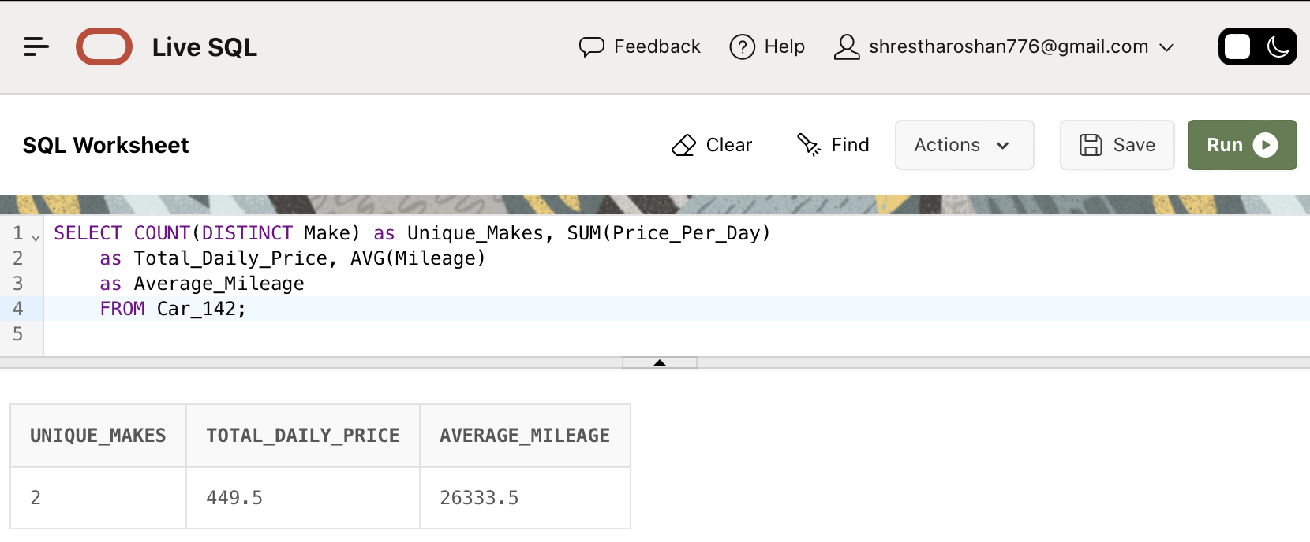SELECT COUNT(DISTINCT Make) as Unique_Makes, SUM(Price_Per_Day) as Total_Daily_Price, AVG(Mileage) as Average_Mileage FROM Car_142;

1. **GROUP BY operator:**

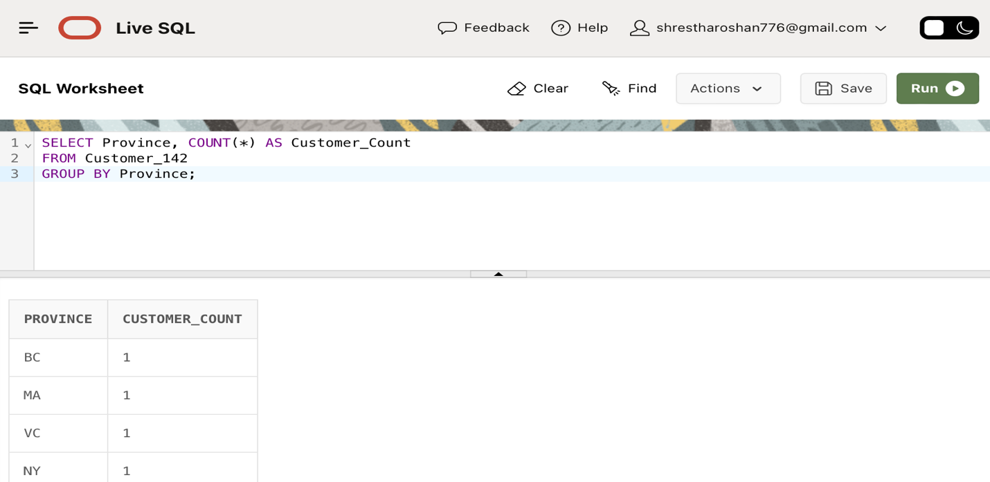SELECT Province, COUNT(*) AS Customer_Count FROM Customer_142 GROUP BY Province;

1. **Group By Having:**

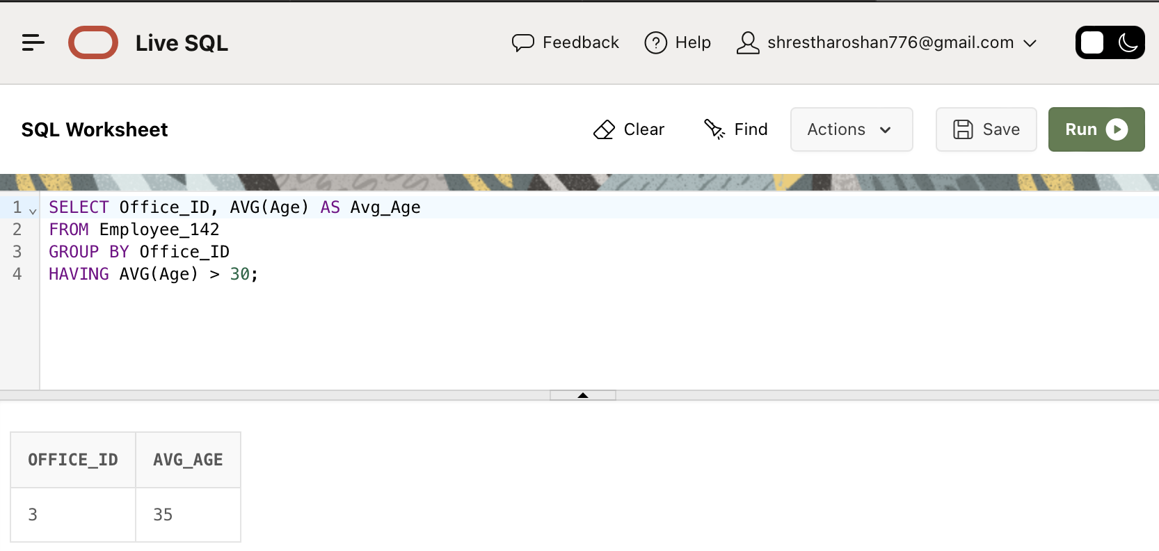SELECT Office_ID, AVG(Age) AS Avg_Age FROM Employee_142 GROUP BY Office_ID HAVING AVG(Age) > 30;

1. 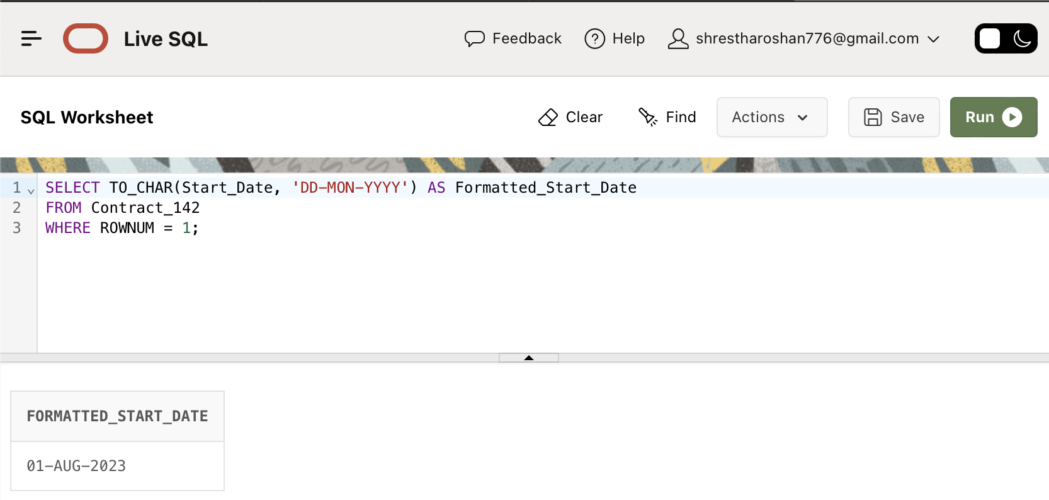**TO_CHAR() function:**SELECT TO_CHAR(Start_Date, 'DD-MON-YYYY') AS Formatted_Start_Date FROM Contract_142 WHERE ROWNUM = 1;
2. **LOWER function:**

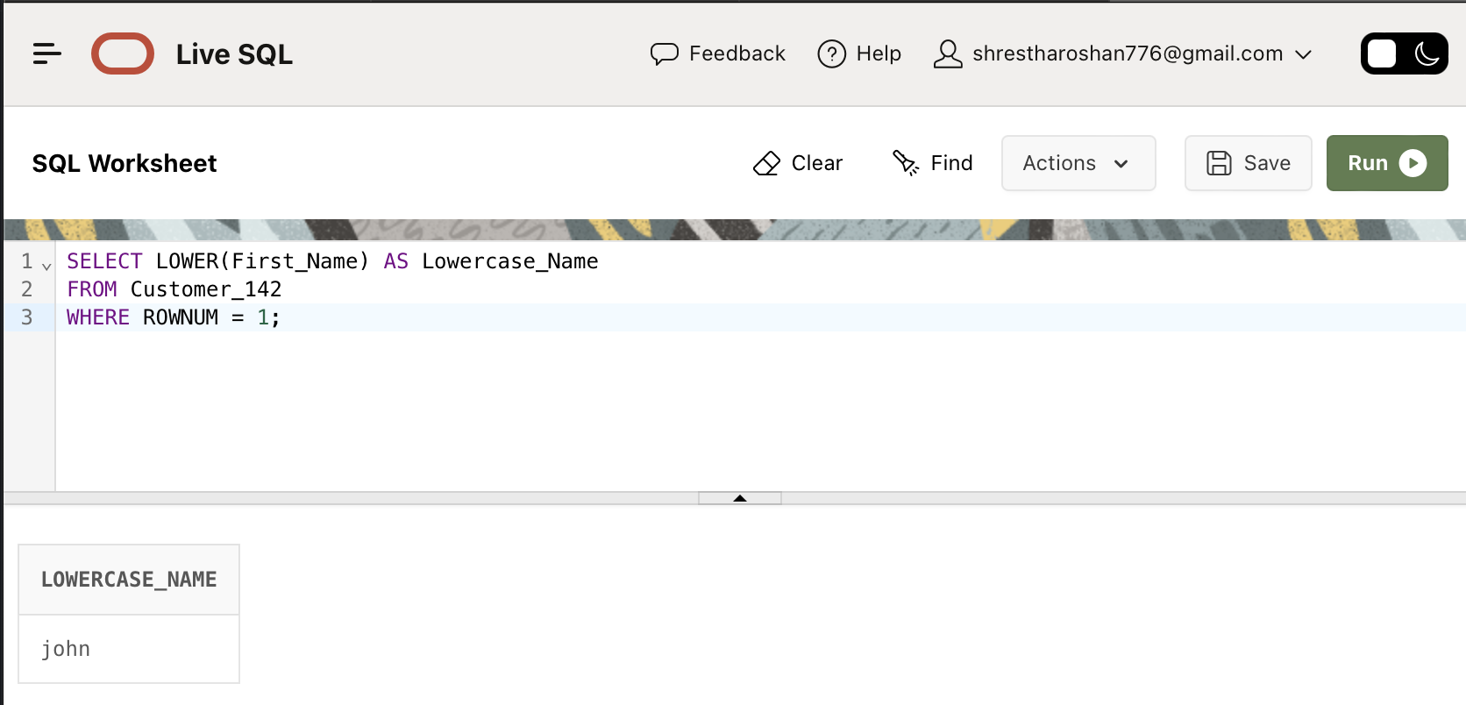SELECT LOWER(First_Name) AS Lowercase_Name FROM Customer_142 WHERE ROWNUM = 1;

1. **UPPER function:**

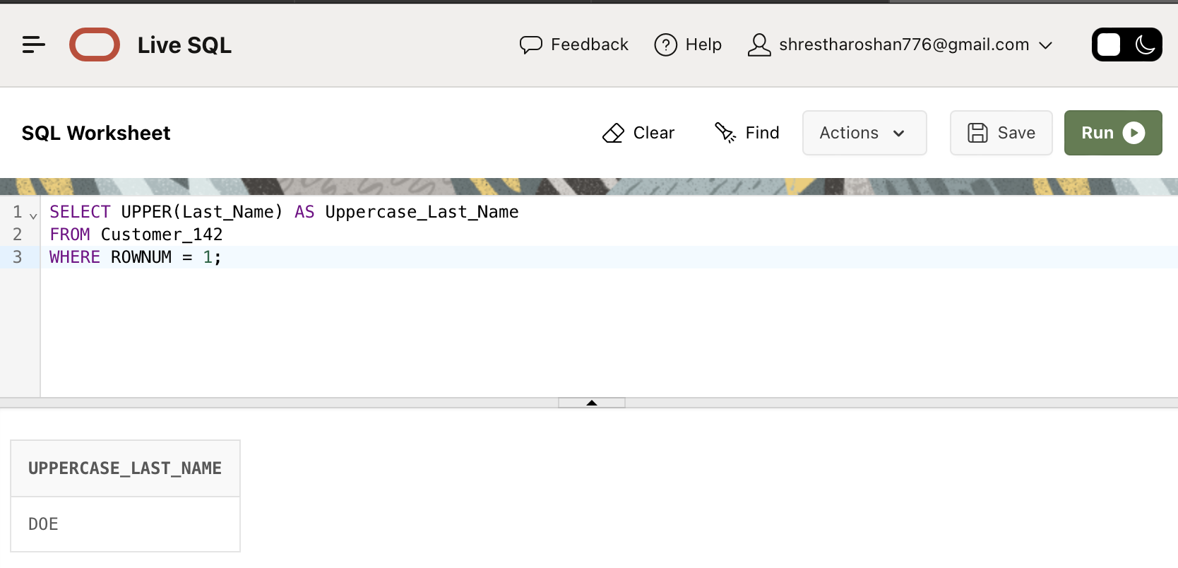SELECT UPPER(Last_Name) AS Uppercase_Last_Name FROM Customer_142 WHERE ROWNUM = 1;

1. **INITCAP function:**

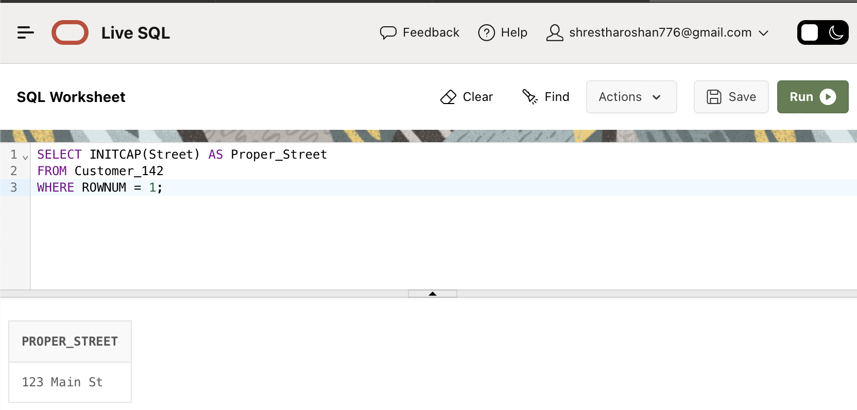SELECT INITCAP(Street) AS Proper_Street FROM Customer_142 WHERE ROWNUM = 1;=

1. **CONCAT function:**

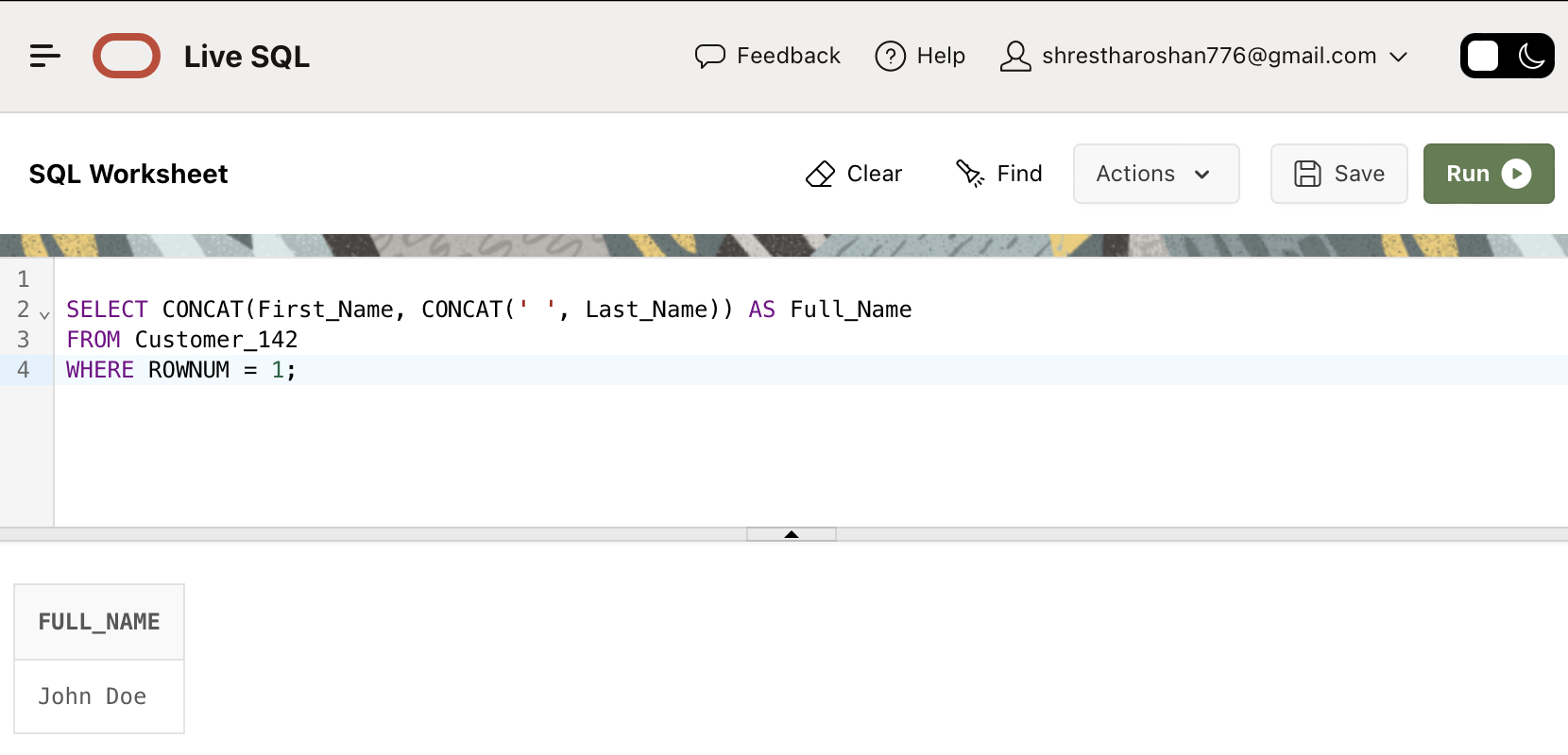SELECT CONCAT(First_Name, CONCAT(' ', Last_Name)) AS Full_Name FROM Customer_142 WHERE ROWNUM = 1;

1. **SUBSTR function:**

SELECT SUBSTR(Phone, 1, 3) AS Area_Code FROM Customer_142 WHERE ROWNUM = 1;

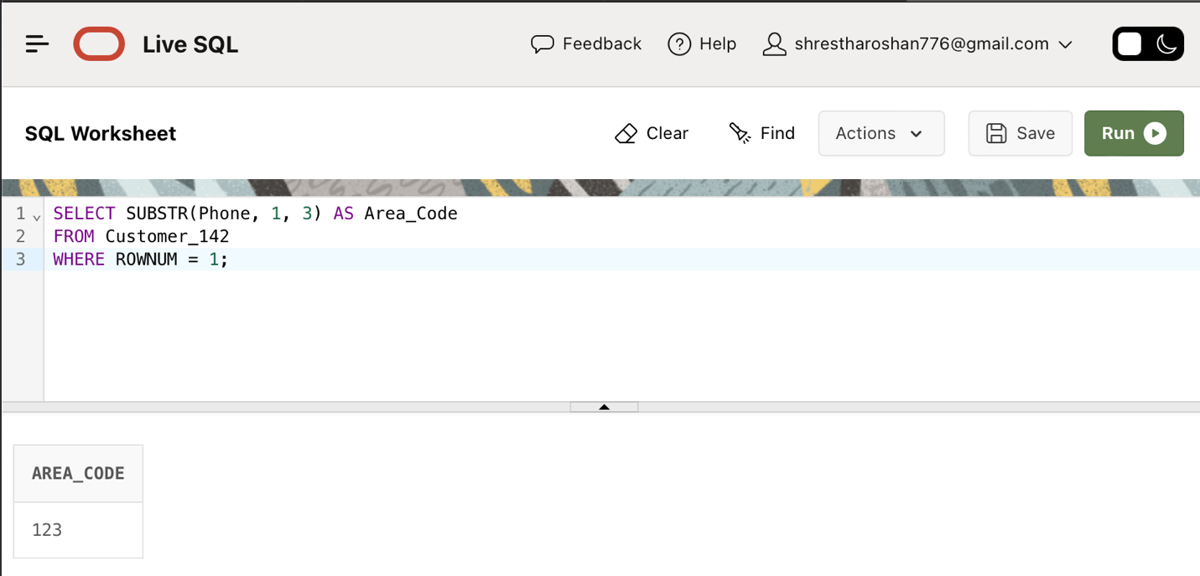

1. **INSTR function:**

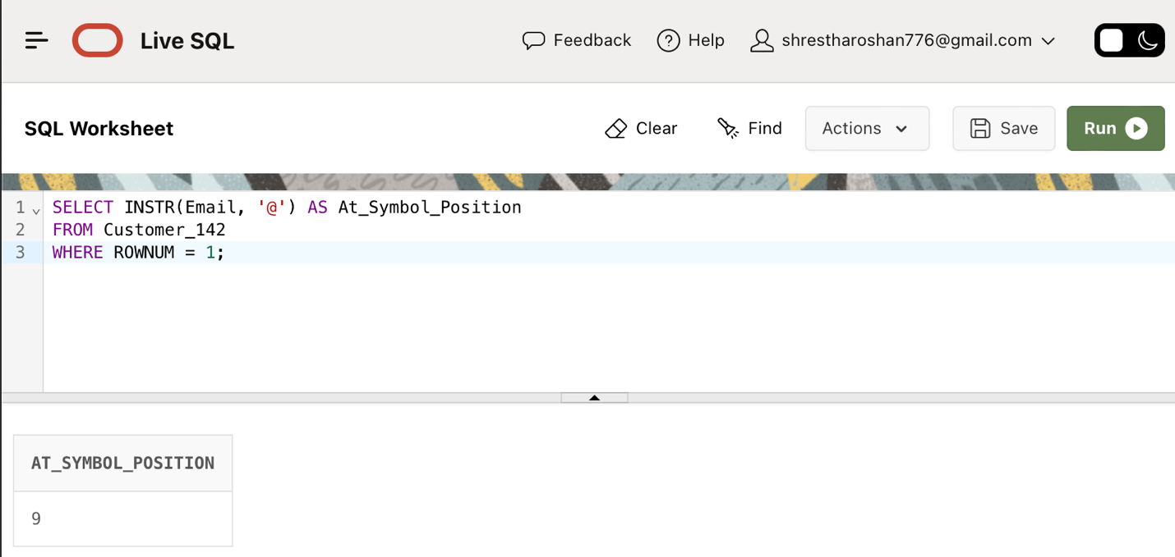SELECT INSTR(Email, '@') AS At_Symbol_Position FROM Customer_142 WHERE ROWNUM = 1;

1. **TRIM function:**

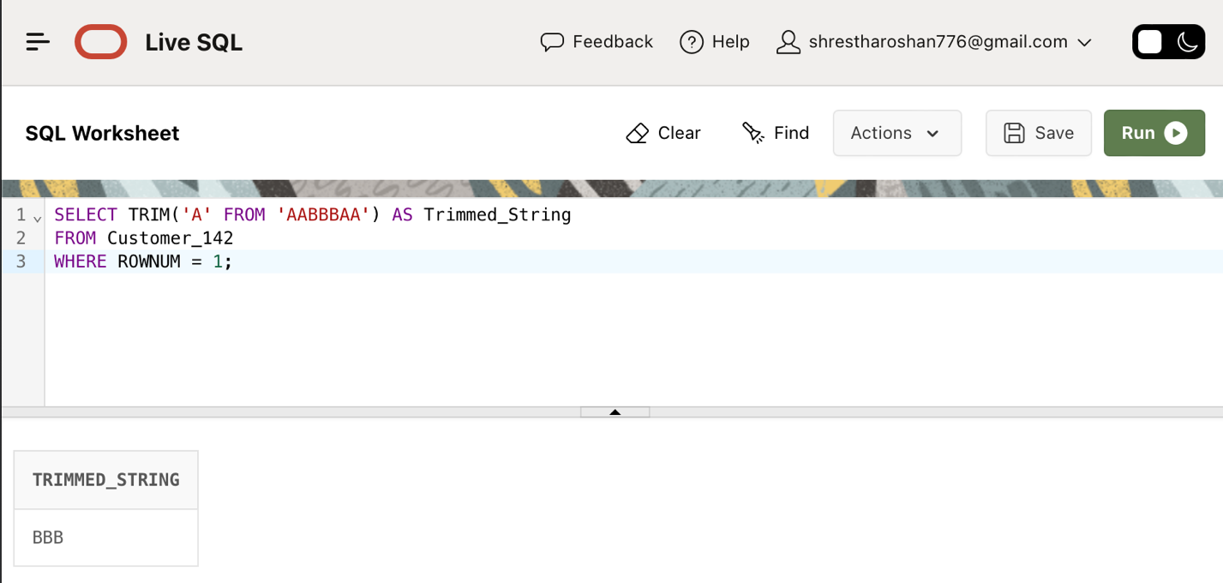SELECT TRIM('A' FROM 'AABBBAA') AS Trimmed_String FROM Customer_142 WHERE ROWNUM = 1;

1. **RPAD function:**

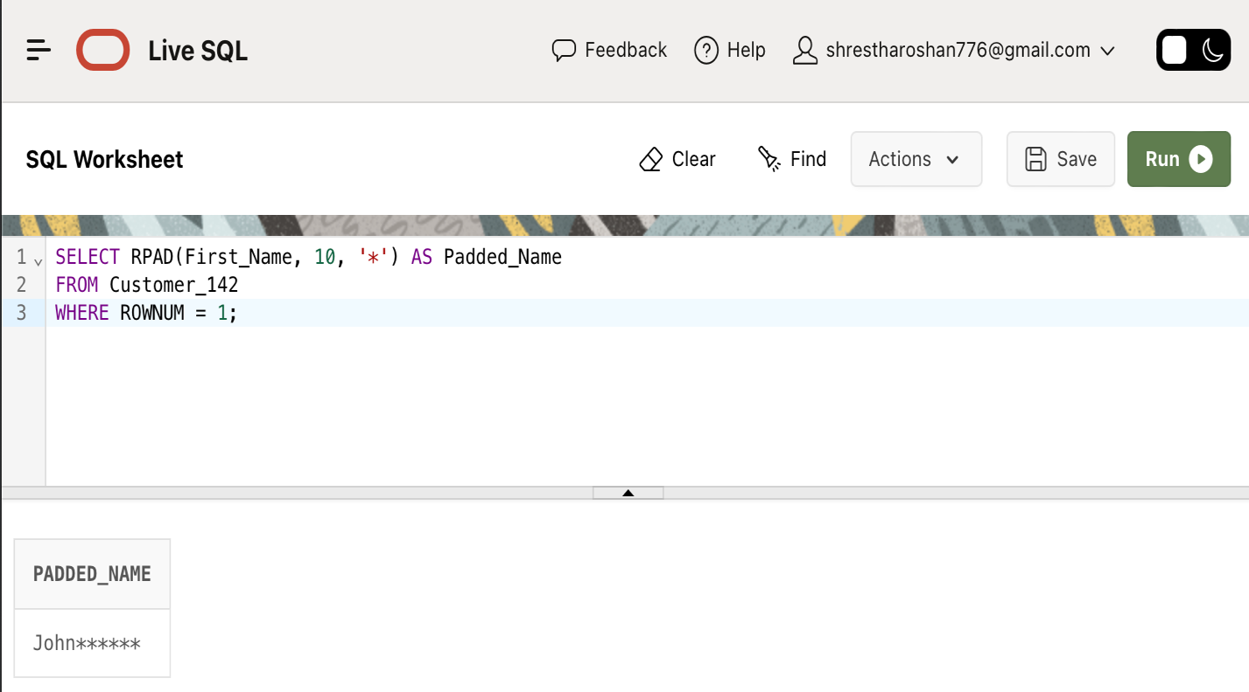SELECT RPAD(First_Name, 10, '*') AS Padded_Name FROM Customer_142 WHERE ROWNUM = 1;

1. **ROUND function:**

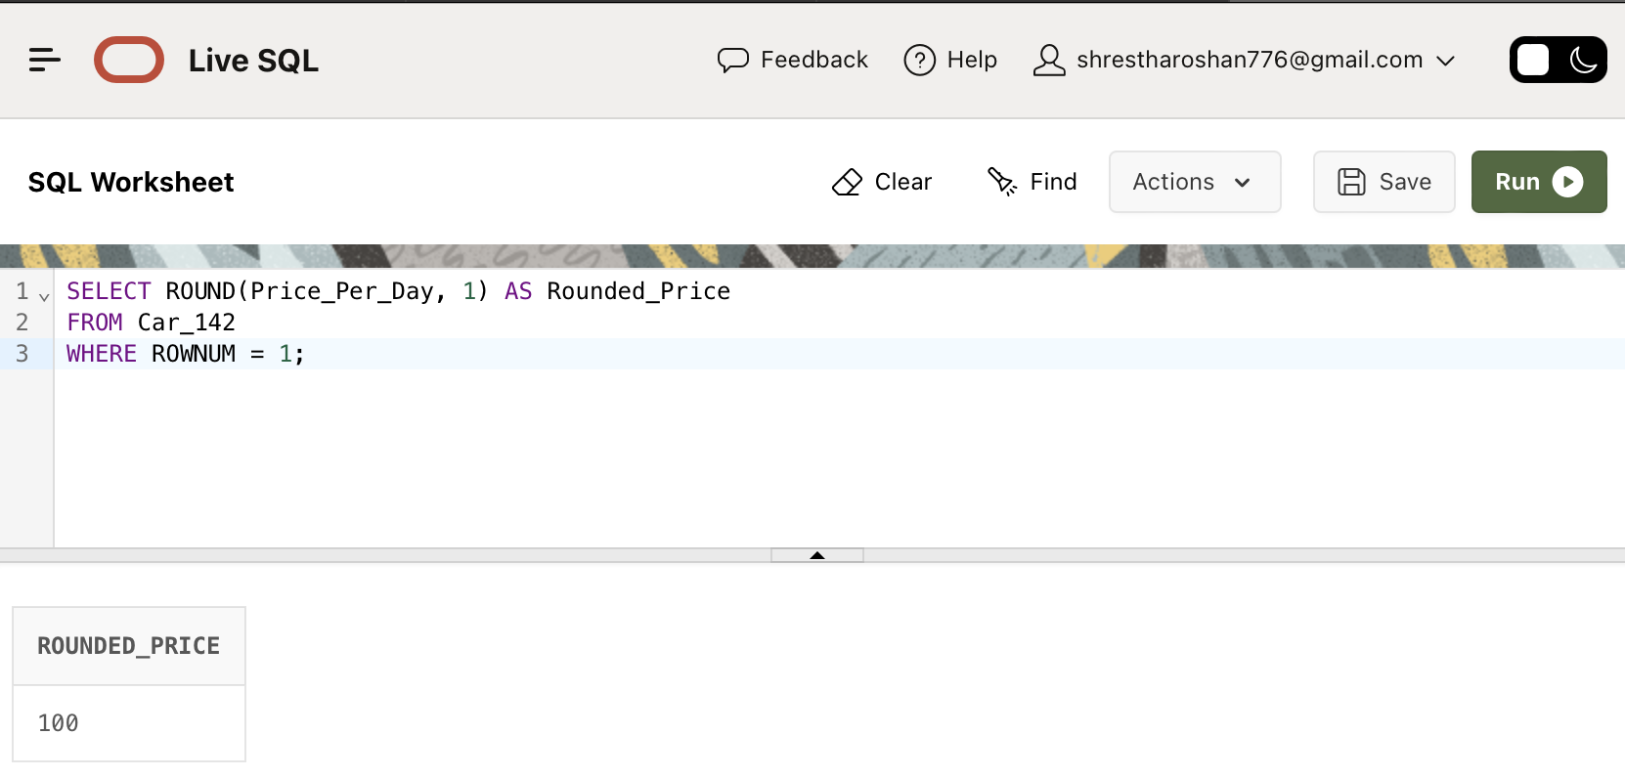SELECT ROUND(Price_Per_Day, 1) AS Rounded_Price FROM Car_142 WHERE ROWNUM = 1;

1. **CELI function:**

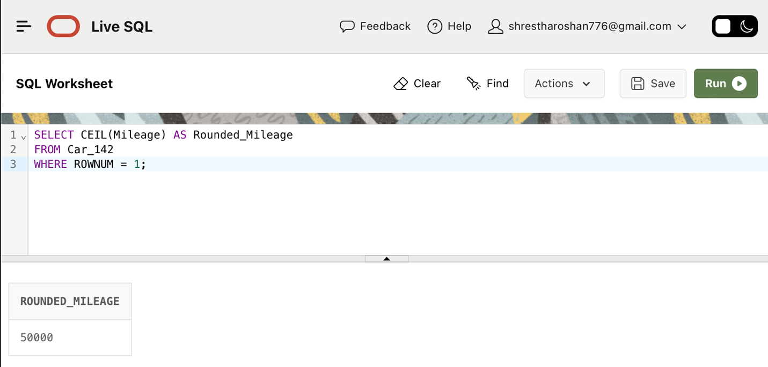SELECT CEIL(Mileage) AS Rounded_Mileage FROM Car_142 WHERE ROWNUM = 1;

1. **NVL function:**

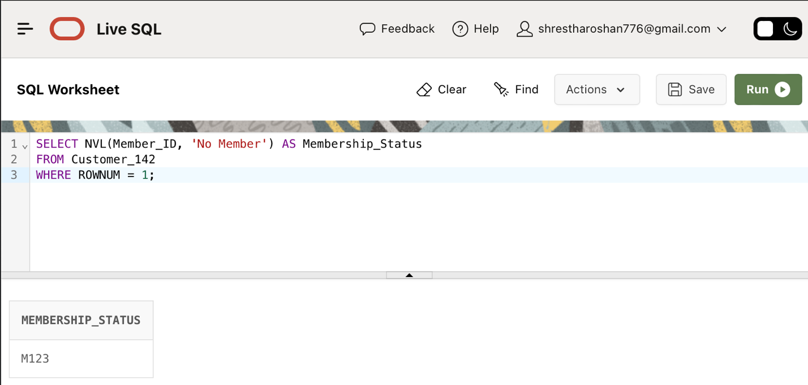SELECT NVL(Member_ID, 'No Member') AS Membership_Status FROM Customer_142 WHERE ROWNUM = 1;

1. **Inner Join:**

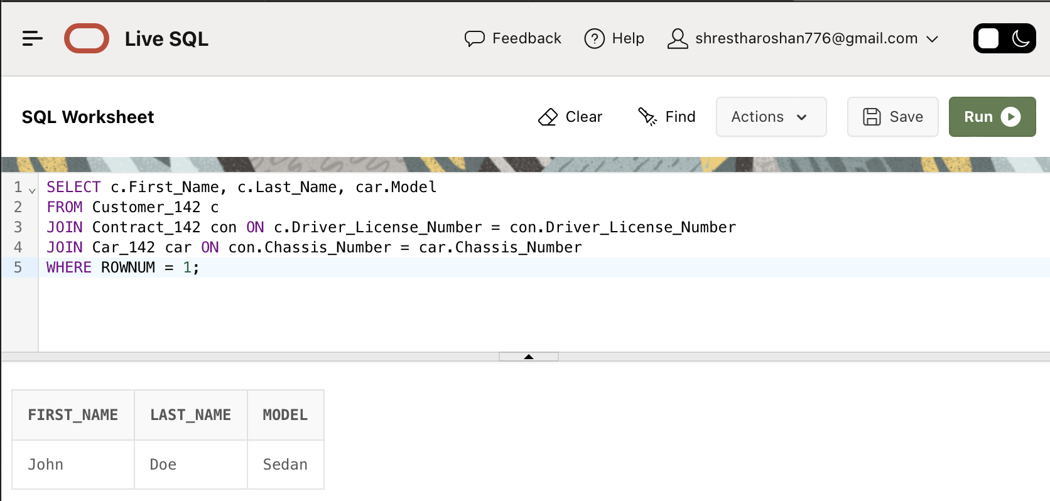SELECT c.First_Name, c.Last_Name, car.Model FROM Customer_142 c JOIN Contract_142 con ON c.Driver_License_Number = con.Driver_License_Number JOIN Car_142 car ON con.Chassis_Number = car.Chassis_Number WHERE ROWNUM = 1;

1. **Left Outer Join:**

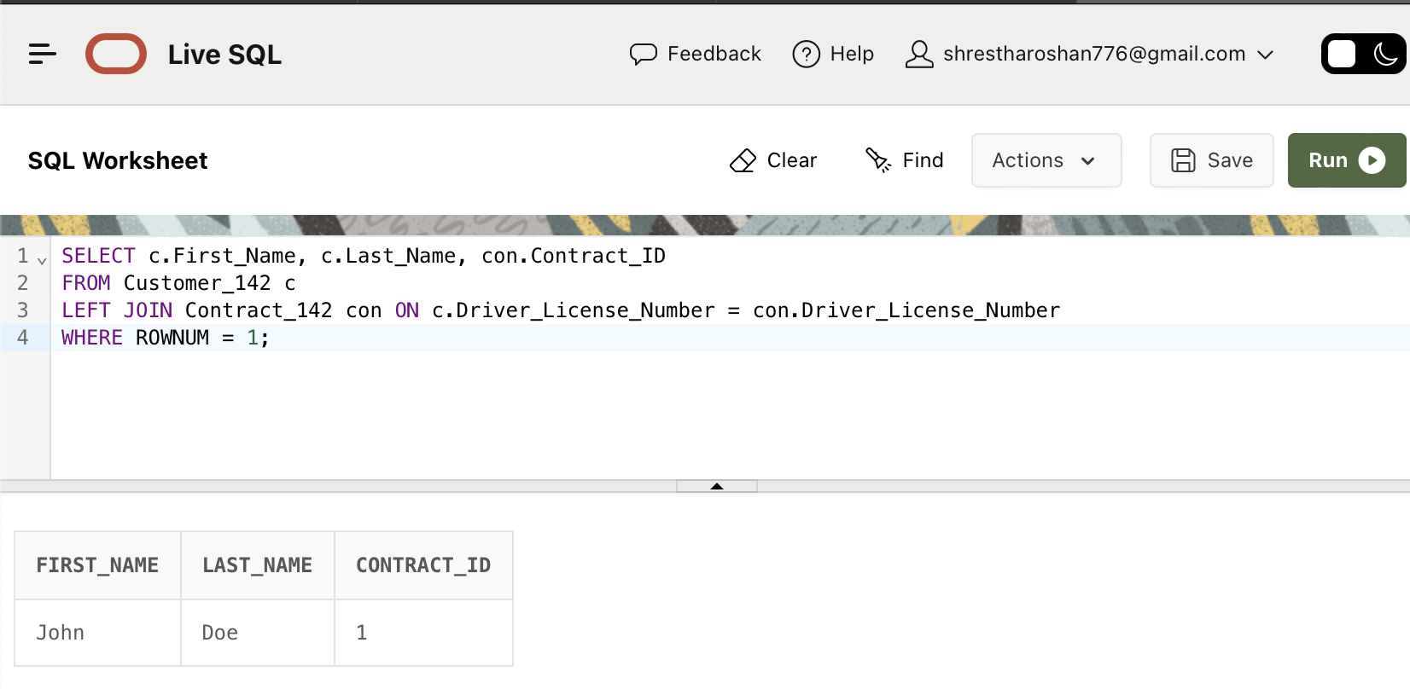SELECT c.First_Name, c.Last_Name, con.Contract_ID FROM Customer_142 c LEFT JOIN Contract_142 con ON c.Driver_License_Number = con.Driver_License_Number WHERE ROWNUM = 1;

1. **Right Outer Join:**

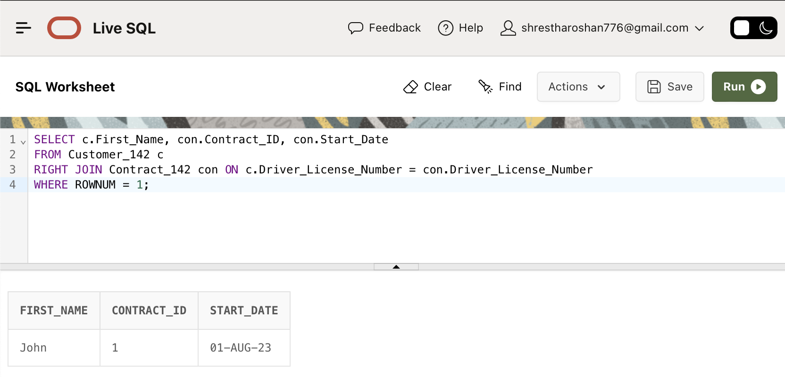SELECT c.First_Name, con.Contract_ID, con.Start_Date FROM Customer_142 c RIGHT JOIN Contract_142 con ON c.Driver_License_Number = con.Driver_License_Number WHERE ROWNUM = 1;

1. **Cross Join:**

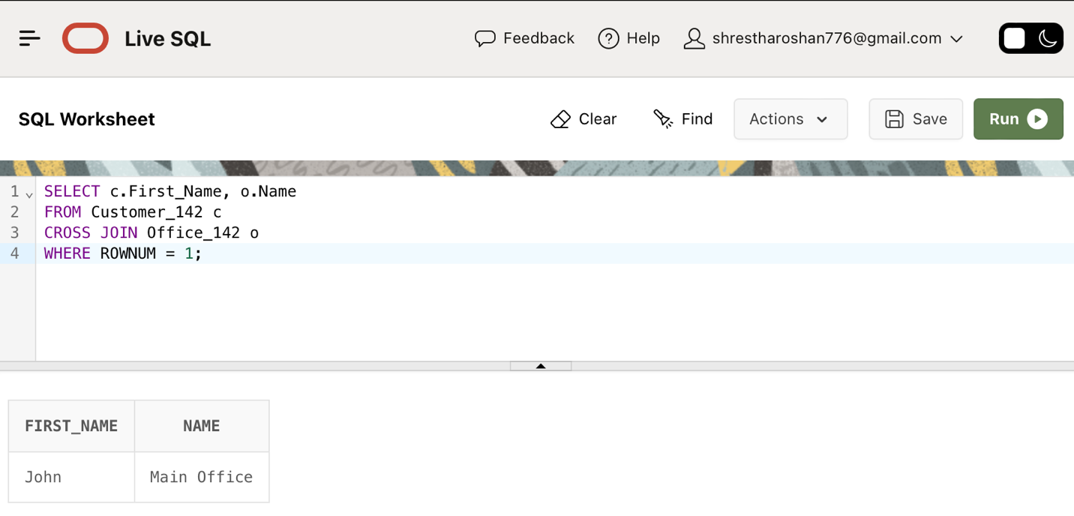SELECT c.First_Name, o.Name FROM Customer_142 c CROSS JOIN Office_142 o WHERE ROWNUM = 1;

1. **Self-Join:**

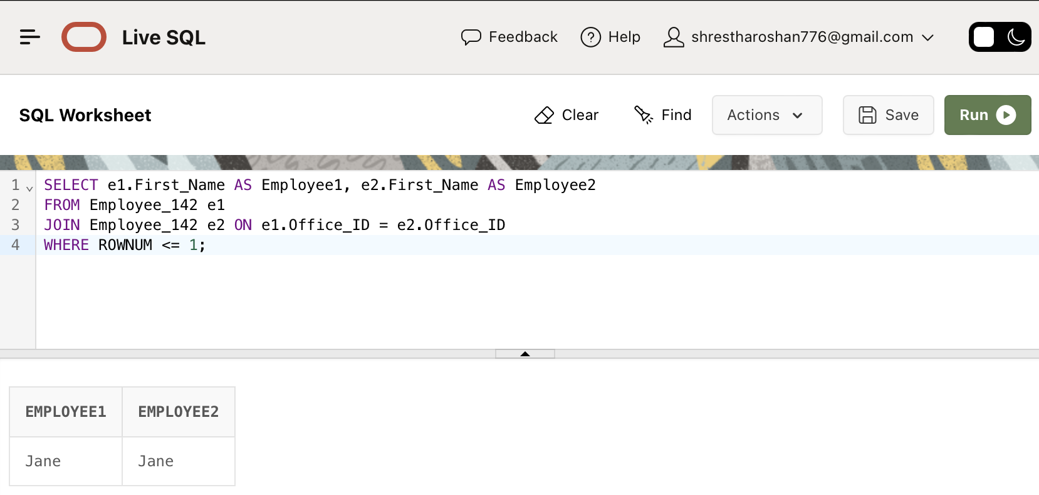SELECT e1.First_Name AS Employee1, e2.First_Name AS Employee2 FROM Employee_142 e1 JOIN Employee_142 e2 ON e1.Office_ID = e2.Office_ID WHERE ROWNUM <= 1;

1. **Single row subqueries:**

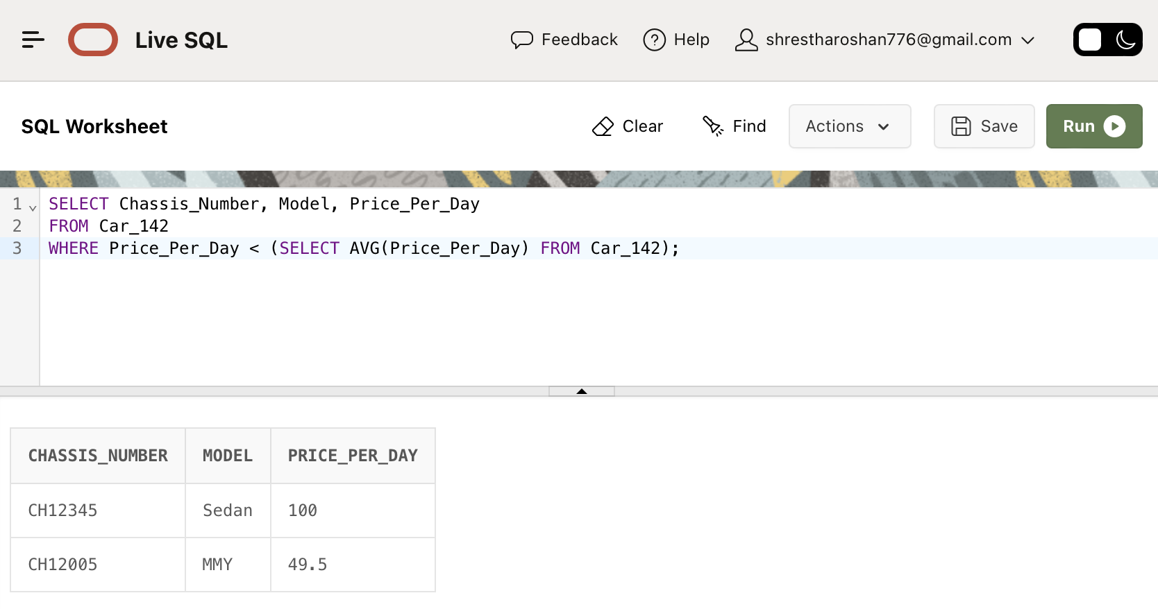SELECT Chassis_Number, Model, Price_Per_Day FROM Car_142 WHERE Price_Per_Day < (SELECT AVG(Price_Per_Day) FROM Car_142);

1. **EXISTS operator:**

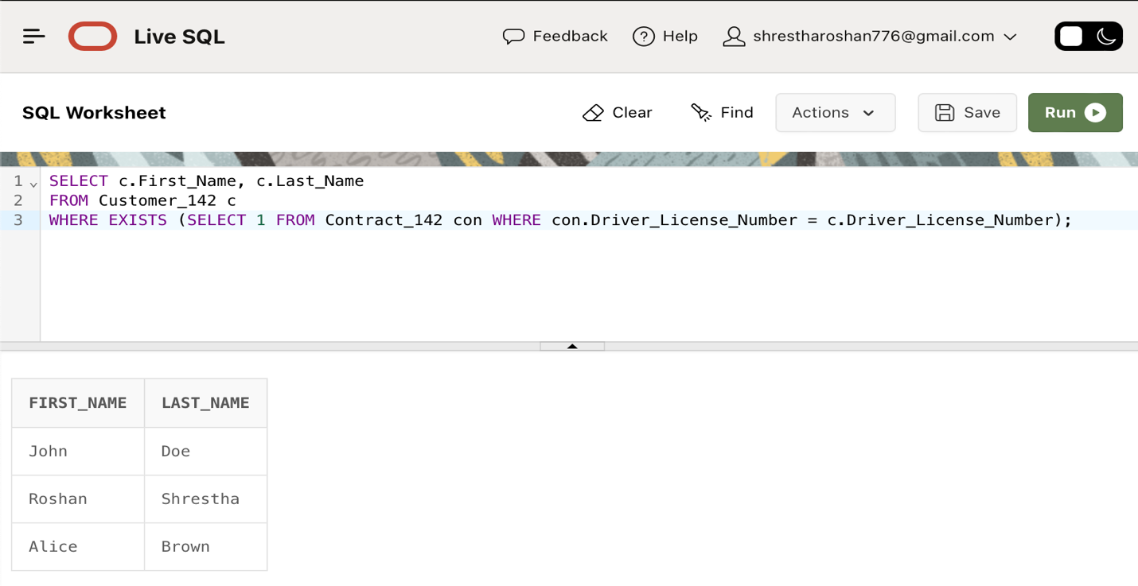SELECT c.First_Name, c.Last_Name FROM Customer_142 c WHERE EXISTS (SELECT 1 FROM Contract_142 con WHERE con.Driver_License_Number = c.Driver_License_Number);

1. **NOT EXISTS operator:**

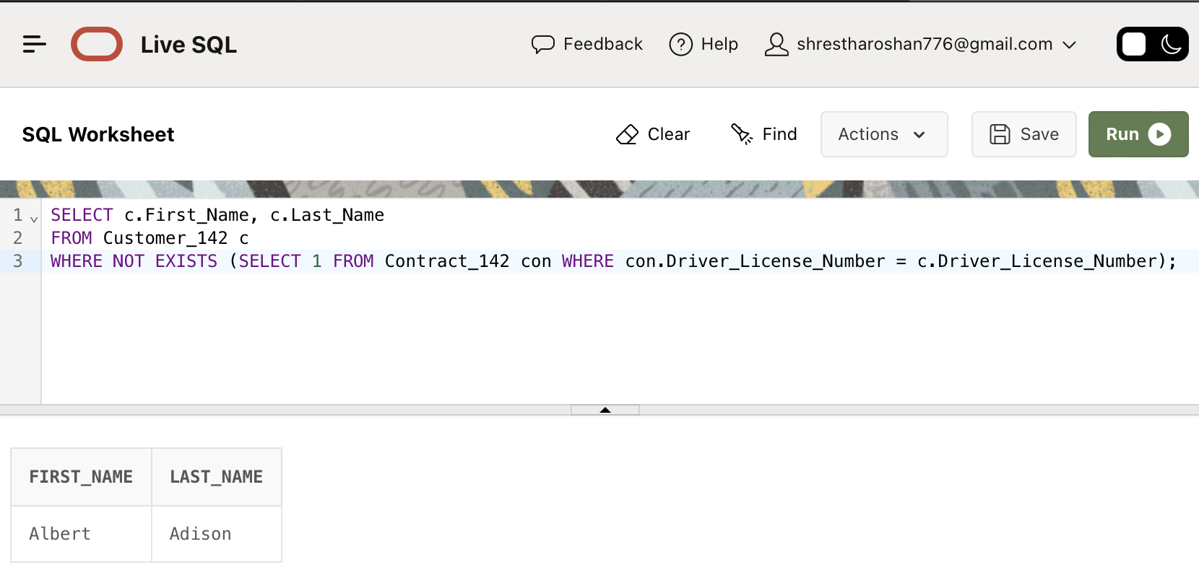SELECT c.First_Name, c.Last_Name FROM Customer_142 c WHERE NOT EXISTS (SELECT 1 FROM Contract_142 con WHERE con.Driver_License_Number = c.Driver_License_Number);

1. **UNION operator:**

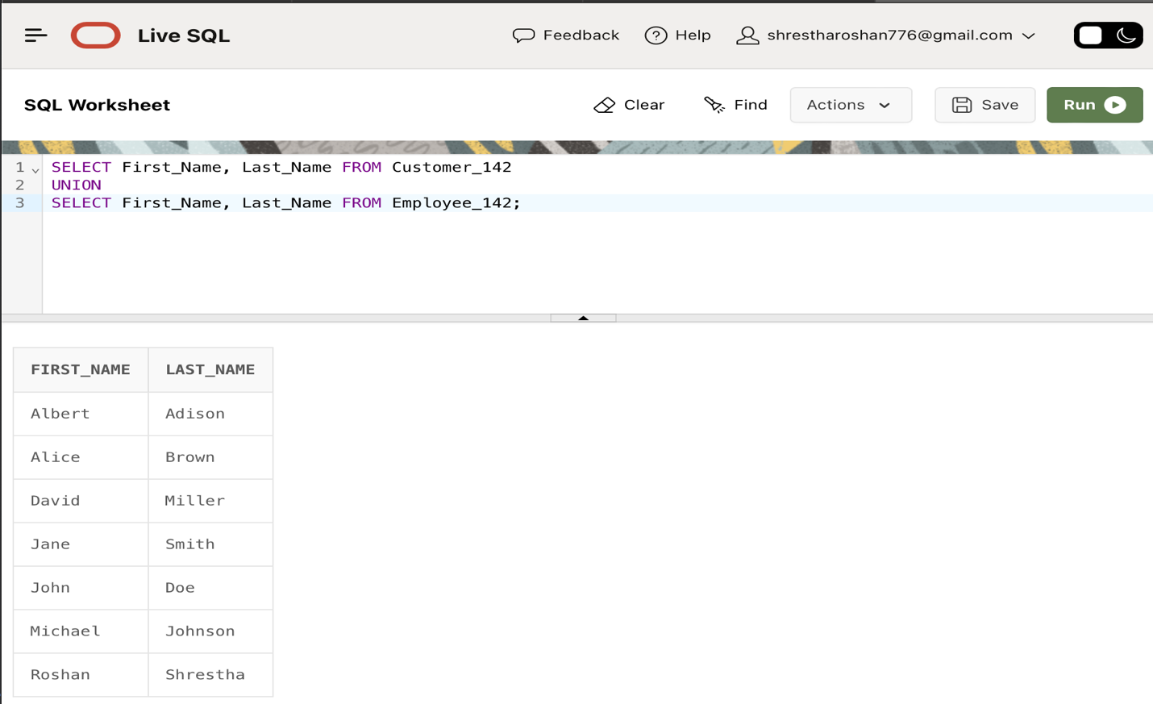SELECT First_Name, Last_Name FROM Customer_142 UNION SELECT First_Name, Last_Name FROM Employee_142;

1. **INTERSECT operator:**

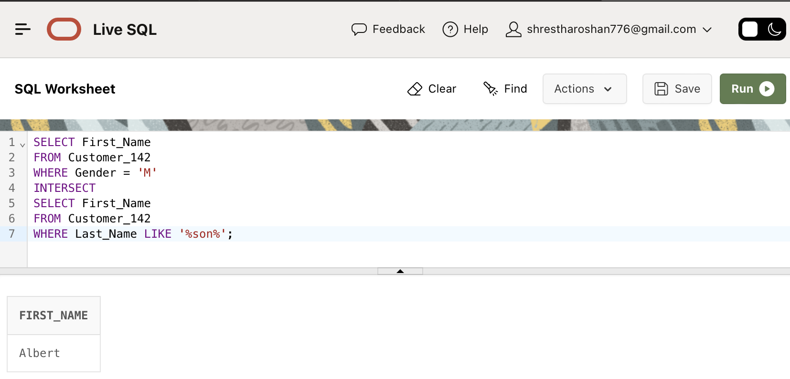SELECT First_Name FROM Customer_142 WHERE Gender = 'M' INTERSECT SELECT First_Name FROM Customer_142 WHERE Last_Name LIKE '%son%';

1. **MINUS operator:**

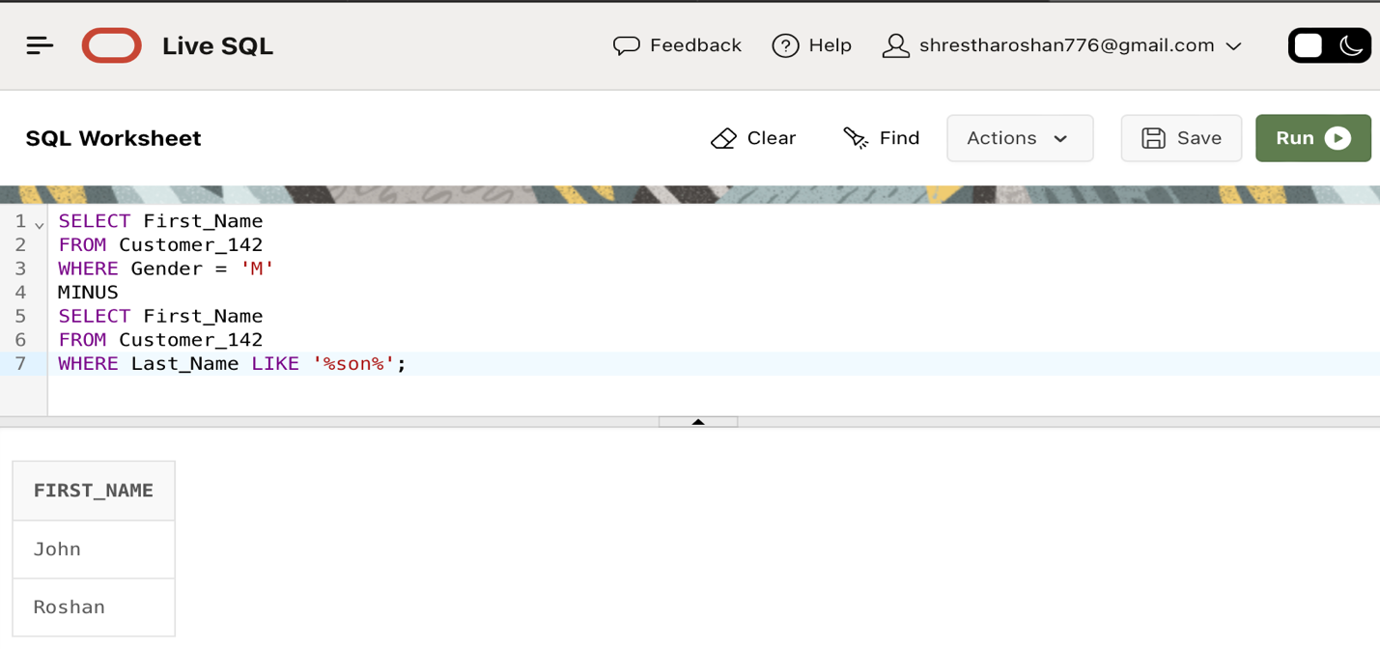SELECT First_Name FROM Customer_142 WHERE Gender = 'M' MINUS SELECT First_Name FROM Customer_142 WHERE Last_Name LIKE '%son%';

1. **Query to List Cars with Most Rentals:**

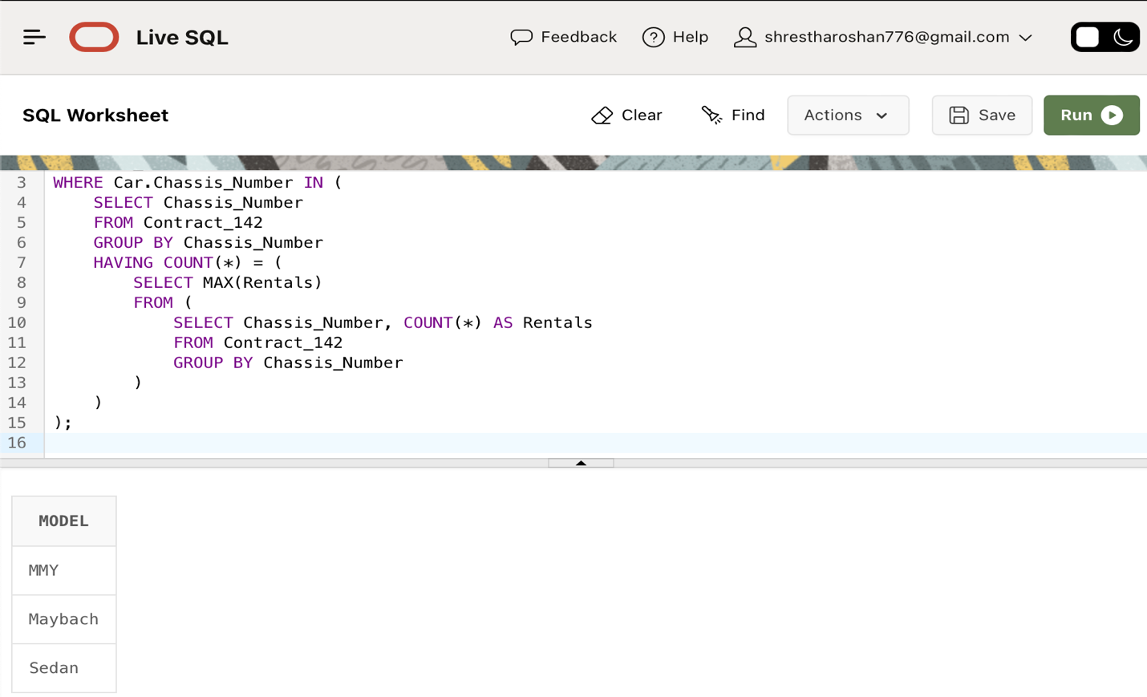SELECT Car.Model FROM Car_142 Car WHERE Car.Chassis_Number IN ( SELECT Chassis_Number FROM Contract_142 GROUP BY Chassis_Number HAVING COUNT() = ( SELECT MAX(Rentals) FROM ( SELECT Chassis_Number, COUNT() AS Rentals FROM Contract_142 GROUP BY Chassis_Number)));

1. **Query to Show Total Payments for Each Customer:**

SELECT C.First_Name, C.Last_Name, P.Total_Amount FROM Customer_142 C JOIN Payment_142 P ON C.Driver_License_Number = P.Driver_License_Number WHERE P.Total_Amount >= ALL ( SELECT MAX(Total_Amount) FROM Payment_142 GROUP BY Driver_License_Number );

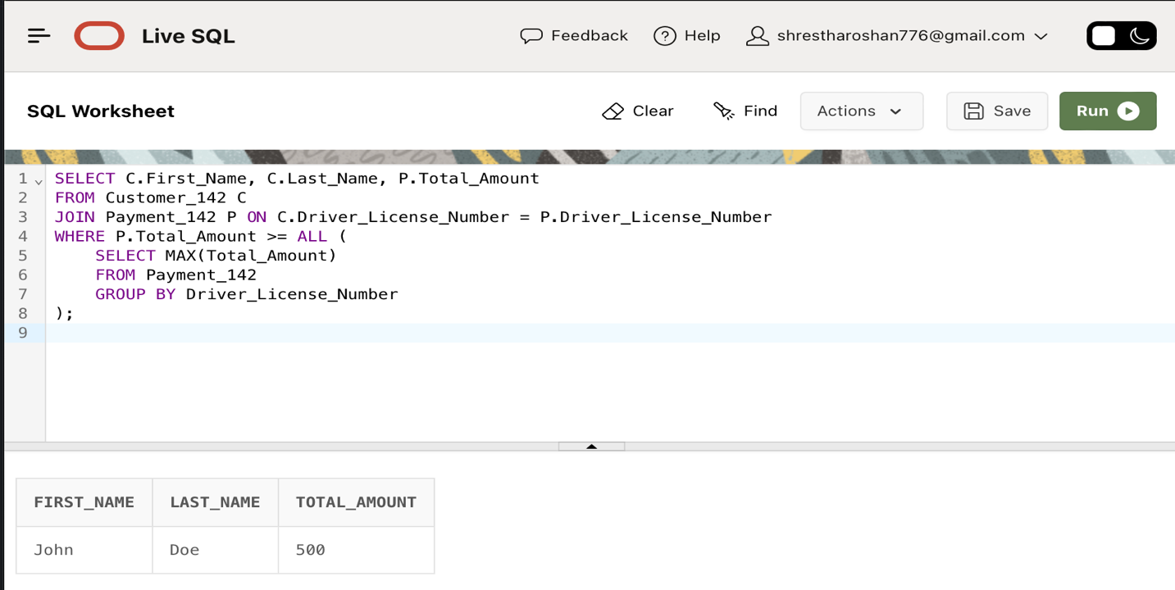

1. **Query to show customer's first and last name who has at least one contract:**

SELECT C.First_Name, C.Last_Name FROM Customer_142 C WHERE NOT EXISTS (

SELECT 1 FROM Contract_142 CO WHERE CO.Driver_License_Number = C.Driver_License_Number);

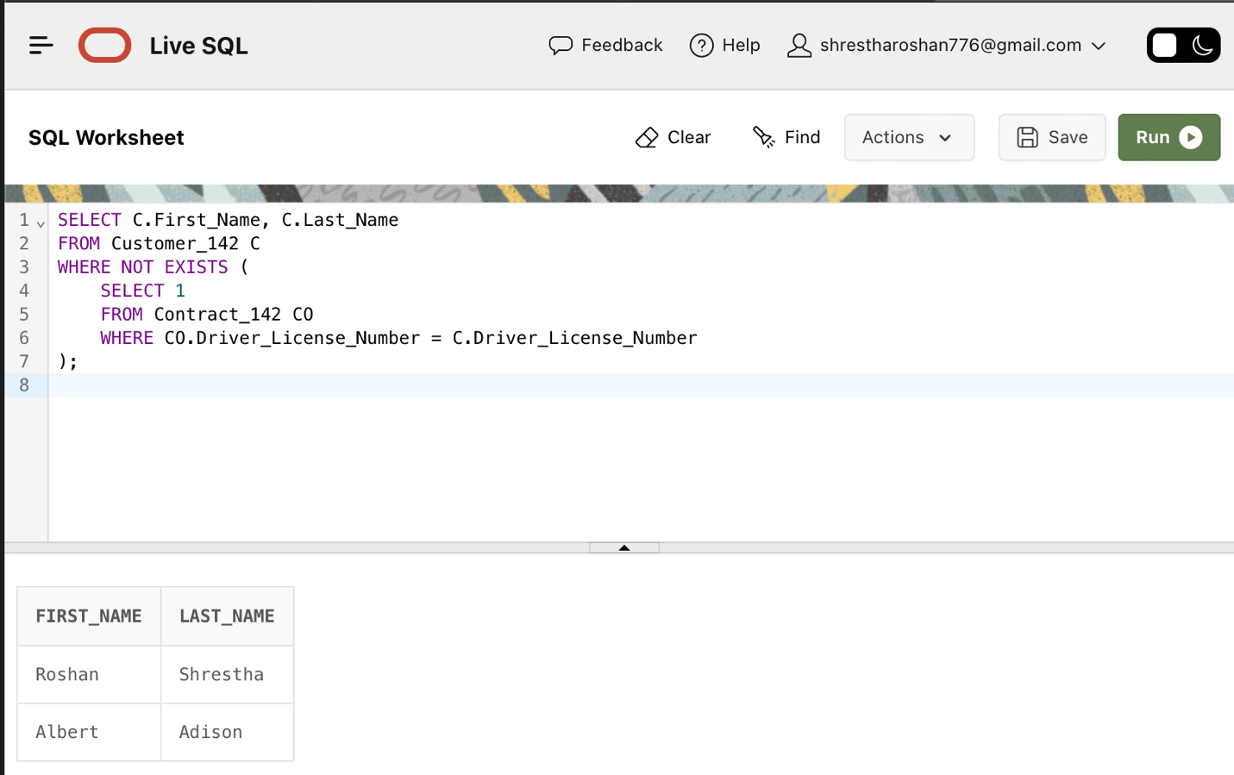

1. **Query to Show Contracts with Insurance Information:**

SELECT CO.Contract_ID, CO.Start_Date, I.Coverage_Type FROM Contract_142 CO JOIN Car_142 Car ON CO.Chassis_Number = Car.Chassis_Number JOIN Insurance_142 I ON Car.Insurance_Code = I.Insurance_Code WHERE CO.Chassis_Number IS NOT NULL;

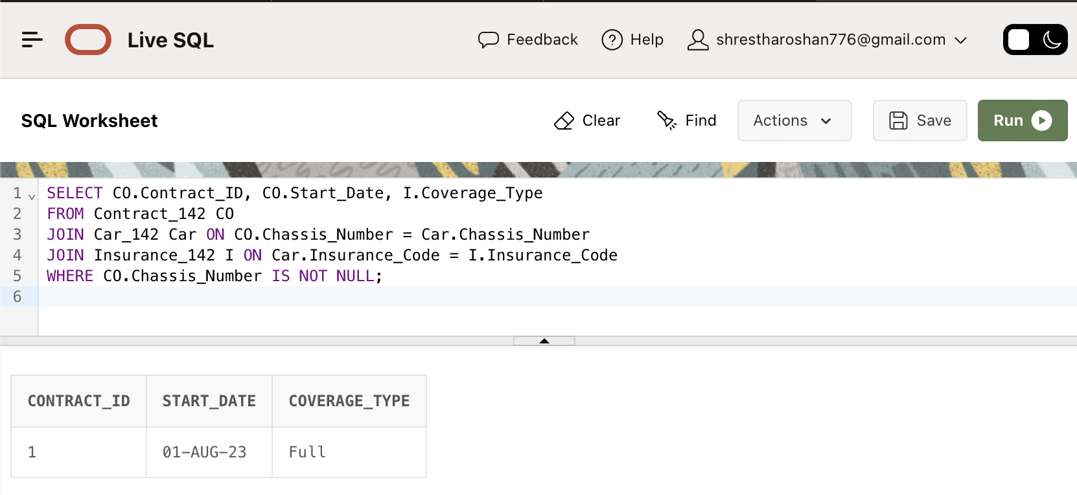

1. **Query to get employee who manage the greatest number of offices based on the number of locations associated with each office:**

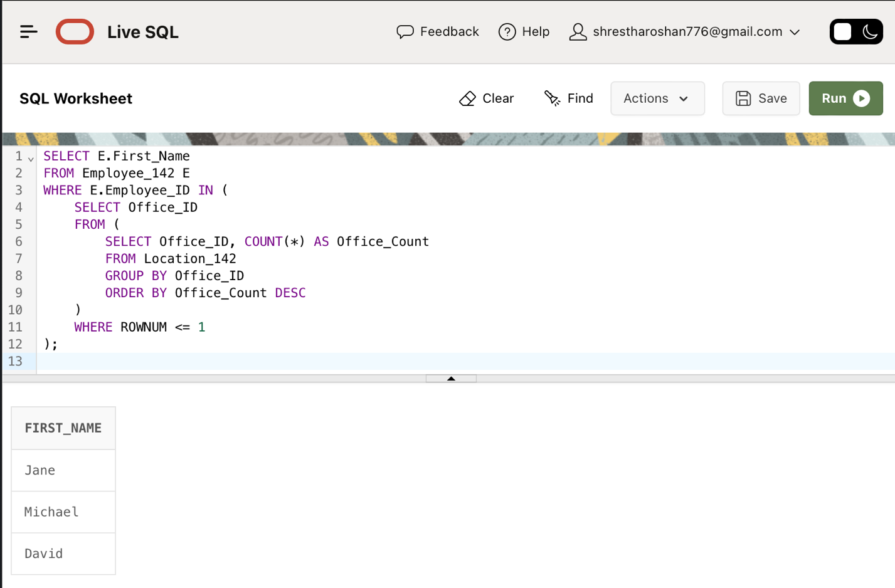SELECT E.First_Name FROM Employee_142 E WHERE E.Employee_ID IN ( SELECT Office_ID FROM ( SELECT Office_ID, COUNT(*) AS Office_Count FROM Location_142 GROUP BY Office_ID ORDER BY Office_Count DESC ) WHERE ROWNUM <= 1 );

1. **Query to find the customers who have rented cars with the highest mileage among all the cars available for rent:**

SELECT First_Name, Last_Name FROM Customer_142 WHERE Driver_License_Number IN ( SELECT Driver_License_Number FROM Contract_142 WHERE Chassis_Number IN ( SELECT Chassis_Number FROM Car_142 WHERE Mileage = ( SELECT MAX(Mileage) FROM Car_142 ) ) );

